St. John Evangelical Lutheran Church Sunday, October 8, 2023
229 South Broad Street
Jersey Shore, PA 17740 19th Sunday after Pentecost
570-398-1676

Children’s Church will meet upstairs in the youth Sunday School room at end of the hallway at 9:30 a.m. Please take your child there before worship begins.

Introduction to the day
In today’s gospel reading, Jesus tells a vineyard parable, which serves as an image of Israel, the prophets’ mission, and Christ’s death. For Christians, the vineyard also speaks of God’s love poured out in the blood of Christ, given to us for the forgiveness of sin. Grafted onto Christ the vine at baptism, we are nourished with wine and bread so that we may share Christ’s sufferings and know the power of his resurrection.

SHARING OUR JOYS AND CONCERNS

PRELUDE

Gathering
The Holy Spirit calls us together as the people of God.

Confession and Forgiveness
The assembly stands. All may make the sign of the cross, the sign that is marked at baptism, as the presiding minister begins.

Blessed be God, the one who forms us,
☩ Jesus who bears the cross,
the Spirit who makes our joy complete.
Amen.
Let us bow before God in humility, confessing our sin.
Silence is kept for reflection.
Steadfast and faithful God,
you have revealed the ways of justice,
yet we fail to follow you.
We are overwhelmed
by the world’s violence and suffering.
We are afraid to risk what we have
for the sake of others.
For the harm we have caused,
known and unknown, forgive us.
For the unjust demands we place on others
and your creation, forgive us.
For the ways we turn away
from you and our neighbor, forgive us.
Lead us back to you
and set us on the right path;
in the name of Jesus Christ, our Savior. Amen.
Beloved in Christ,
God’s justice stretches beyond all understanding.
God’s compassion is beyond compare.
In Jesus, God is always making a new way for us.
In ☩ Christ, you are already and always forgiven. Amen.

Gathering Song: We Plow the Fields and Scatter 681

Greeting
P: The grace of our Lord Jesus Christ, the love of God,
and the communion of the Holy Spirit be with you all.
C: And also, with you.

Hymn of PRAISE: Jesus Loves Me 595

Prayer of the Day
P: Let us pray.
Beloved God, from you come all things that are good. Lead us by the inspiration of your Spirit to know those things that are right, and by your merciful guidance, help us to do them, through Jesus Christ, our Savior and Lord. Amen.
The assembly is seated.
Word
God speaks to us in scripture reading, preaching, and song.

L: A reading from Isaih

First Reading: Isaiah 5:1-7
The prophet sings a sad, parable-like love song about the relationship between God and Israel. In this song Israel is compared to a promising vineyard. Despite God’s loving care, the vineyard that is Israel has brought forth “wild grapes” of injustice and distress, when fine grapes of justice and righteousness were expected.
¹Let me sing for my beloved
my love-song concerning his vineyard:
My beloved had a vineyard
on a very fertile hill.
²He dug it and cleared it of stones,
and planted it with choice vines;
he built a watchtower in the midst of it,
and hewed out a wine vat in it;
he expected it to yield grapes,
but it yielded wild grapes.
³And now, inhabitants of Jerusalem
and people of Judah,
judge between me
and my vineyard.
⁴What more was there to do for my vineyard
that I have not done in it?
When I expected it to yield grapes,
why did it yield wild grapes?
⁵And now I will tell you
what I will do to my vineyard.
I will remove its hedge,
and it shall be devoured;
I will break down its wall,
and it shall be trampled down.
⁶I will make it a waste;
it shall not be pruned or hoed,
and it shall be overgrown with briers and thorns;
I will also command the clouds
that they rain no rain upon it.
⁷For the vineyard of the Lord of hosts
is the house of Israel,
and the people of Judah
are his pleasant planting;
he expected justice,
but saw bloodshed;
righteousness,
but heard a cry!

L: The word of the Lord.
C: Thanks be to God.

L Let us read the Psalm responsively by verse

Psalm: Psalm 80:7-15
⁷Restore us, O God of hosts;
let your face shine upon us, and we shall be saved.
⁸You have brought a vine out of Egypt;
you cast out the nations and planted it.
⁹You cleared the ground for it;
it took root and filled the land.
¹⁰The mountains were covered by its shadow
and the towering cedar trees by its boughs.
¹¹You stretched out its tendrils to the sea
and its branches to the river.
¹²Why have you broken down its wall,
so that all who pass by pluck off its grapes?
¹³The wild boar of the forest has ravaged it,
and the beasts of the field have grazed upon it.
¹⁴Turn now, O God of hosts,
look down from heaven;
¹⁵behold and tend this vine;
preserve what your right hand has planted.

L: A reading from Philippians

Second Reading: Philippians 3:4b-14
Paul reviews some of his supposed credentials, which no longer have any bearing in comparison to the right relationship he has been given through the death of Christ. The power of Christ’s resurrection motivates him to press on toward the ultimate goal, eternal life with Christ.
[Paul writes:] ^{4b}If anyone else has reason to be confident in the flesh, I have more: ⁵circumcised on the eighth day, a member of the people of Israel, of the tribe of Benjamin, a Hebrew born of Hebrews; as to the law, a Pharisee; ⁶as to zeal, a persecutor of the church; as to righteousness under the law, blameless.
⁷Yet whatever gains I had, these I have come to regard as loss because of Christ. ⁸More than that, I regard everything as loss because of the surpassing value of knowing Christ Jesus my Lord. For his sake I have suffered the loss of all things, and I regard them as rubbish, in order that I may gain Christ ⁹and be found in him, not having a righteousness of my own that comes from the law, but one that comes through faith in Christ, the righteousness from God based on faith. ¹⁰I want to know Christ and the power of his resurrection and the sharing of his sufferings by becoming like him in his death, ¹¹if somehow I may attain the resurrection from the dead.
¹²Not that I have already obtained this or have already reached the goal; but I press on to make it my own, because Christ Jesus has made me his own. ¹³Beloved, I do not consider that I have made it my own; but this one thing I do: forgetting what lies behind and straining forward to what lies ahead, ¹⁴I press on toward the goal for the prize of the heavenly call of God in Christ Jesus.

L: The word of the Lord.
C: Thanks be to God.

The assembly stands.
Gospel Acclamation p.142
Alleluia Lord to whom shall we go?
You have the words of eternal life. Alleluia, Alleluia.

P: The holy gospel according to Matthew
C: Glory to you, O Lord.

Gospel: Matthew 21:33-46
Jesus tells a parable to the religious leaders who are plotting his death, revealing that their plans will, ironically, bring about the fulfillment of scripture.
[Jesus said to the people:] ³³“Listen to another parable. There was a landowner who planted a vineyard, put a fence around it, dug a wine press in it, and built a watchtower. Then he leased it to tenants and went to another country. ³⁴When the harvest time had come, he sent his slaves to the tenants to collect his produce. ³⁵But the tenants seized his slaves and beat one, killed another, and stoned another. ³⁶Again he sent other slaves, more than the first; and they treated them in the same way. ³⁷Finally he sent his son to them, saying, ‘They will respect my son.’ ³⁸But when the tenants saw the son, they said to themselves, ‘This is the heir; come, let us kill him and get his inheritance.’ ³⁹So they seized him, threw him out of the vineyard, and killed him. ⁴⁰Now when the owner of the vineyard comes, what will he do to those tenants?” ⁴¹They said to him, “He will put those wretches to a miserable death, and lease the vineyard to other tenants who will give him the produce at the harvest time.”
⁴²Jesus said to them, “Have you never read in the scriptures:
‘The stone that the builders rejected
has become the cornerstone;
this was the Lord’s doing,
and it is amazing in our eyes’?
⁴³Therefore I tell you, the kingdom of God will be taken away from you and given to a people that produces the fruits of the kingdom. ⁴⁴The one who falls on this stone will be broken to pieces; and it will crush anyone on whom it falls.”
⁴⁵When the chief priests and the Pharisees heard his parables, they realized that he was speaking about them. ⁴⁶They wanted to arrest him, but they feared the crowds, because they regarded him as a prophet.

P: The gospel of the Lord.
C: Praise to you, O Christ.
The assembly is seated.

Sermon
The assembly stands.
Hymn of the Day: The Church of Christ, In Every Age 729

Apostles Creed ( p. 105 at the beginning of the hymnal)

Prayers of Intercession
A: Trusting in the transformative power of God’s loving Spirit, let us pray for the church, the world, and all in need.
A brief silence.
God of all grace, you are the source of life and joy. Strengthen the resolve of your church throughout the world (global mission partners may be named), that together we press on toward the goal of your heavenly call in Jesus Christ. God of grace,
C: hear our prayer.
A: God of all creation, you plant and nourish the earth as your own precious vineyard. Bless fields and orchards and the hands of those who labor in them, that your people are fed with an abundant harvest of good fruit. God of grace,
C: hear our prayer.
A: God of all the earth, you desire peace and justice between nations and peoples. Guide leaders of nations, states, provinces, and cities, that they faithfully govern your people with wisdom, integrity, and compassion. God of grace,
C: hear our prayer.
A: God of all compassion, in Christ, you lovingly poured yourself out like wine for your people. Have mercy on all who mourn, who struggle with their mental health, who cry out for justice, who hunger, and all in any need (especially). God of grace,
C: hear our prayer.
A: God of all steadfastness, you set Christ as the cornerstone and foundation of the church. Build up this congregation as living stones, that it stands in the community as a witness to your enduring faithfulness and love. God of grace,
C: hear our prayer.
A: Gracious God, we uplift the people of Liberia as they will elect a president and parliament leaders in their government this week. May their elections be fair and honest seeking people who will lead with peace and justice for all in their nation. God of grace
C: hear our prayer.
Here other intercessions may be offered.
A: God of all hope, the saints who came before us lived and died with their hearts fixed on you. We give you thanks for their faithful witness, and we wait with hope for the great day when we join their voices in praise. God of grace,
C: hear our prayer.
P: Gracious God, into your hands we commend all for whom we pray, trusting in your unending love and amazing grace; through Jesus Christ, our Savior.
Amen.
The assembly is seated.
CHOIR ANTHEM Anchored in the Rock

A TIME OF SILENT MEDITATION
The assembly stands.
Offering Prayer
A: God of power, God of plenty, all things belong to you.
We bring your gifts to the table, that all might be fed.
Form us into the body of your Beloved, Jesus Christ, our Savior. Amen.

gREAT THANKSGIVING p.144 (in the beginning of the hymnal)
Dialogue
Holy Holy Holy

Thanksgiving at the Table
Words of Institution

THE LORD’S PRAYER P 145 (in the beginning of the hymnal)

Invitation to Communion
P: Jesus invites you to this table.
Come, eat and live.

Communion
When giving the bread and cup, the communion ministers say
The body of Christ, given for you.
The blood of Christ, shed for you.
and each person may respond Amen.

Communion Song Lamb of God You Take Away p.146

Song after Communion Jesus, Remember Me
Jesus, remember me when you come into your kingdom.
Jesus, remember me when you come into your kingdom.

Prayer after Communion
A Blessed be your name, O God, for we have feasted on your Word,
Christ Jesus, the joy and delight of our hearts.
Strengthened by this food, send us to gather the world to your banquet,
where none are left out and all are satisfied.
In Jesus’ name we pray. Amen.

Sending
God blesses us and sends us in mission to the world.

Blessing

Sending Song: There’s a Wideness in God’s Mercy (traditional tune) 588

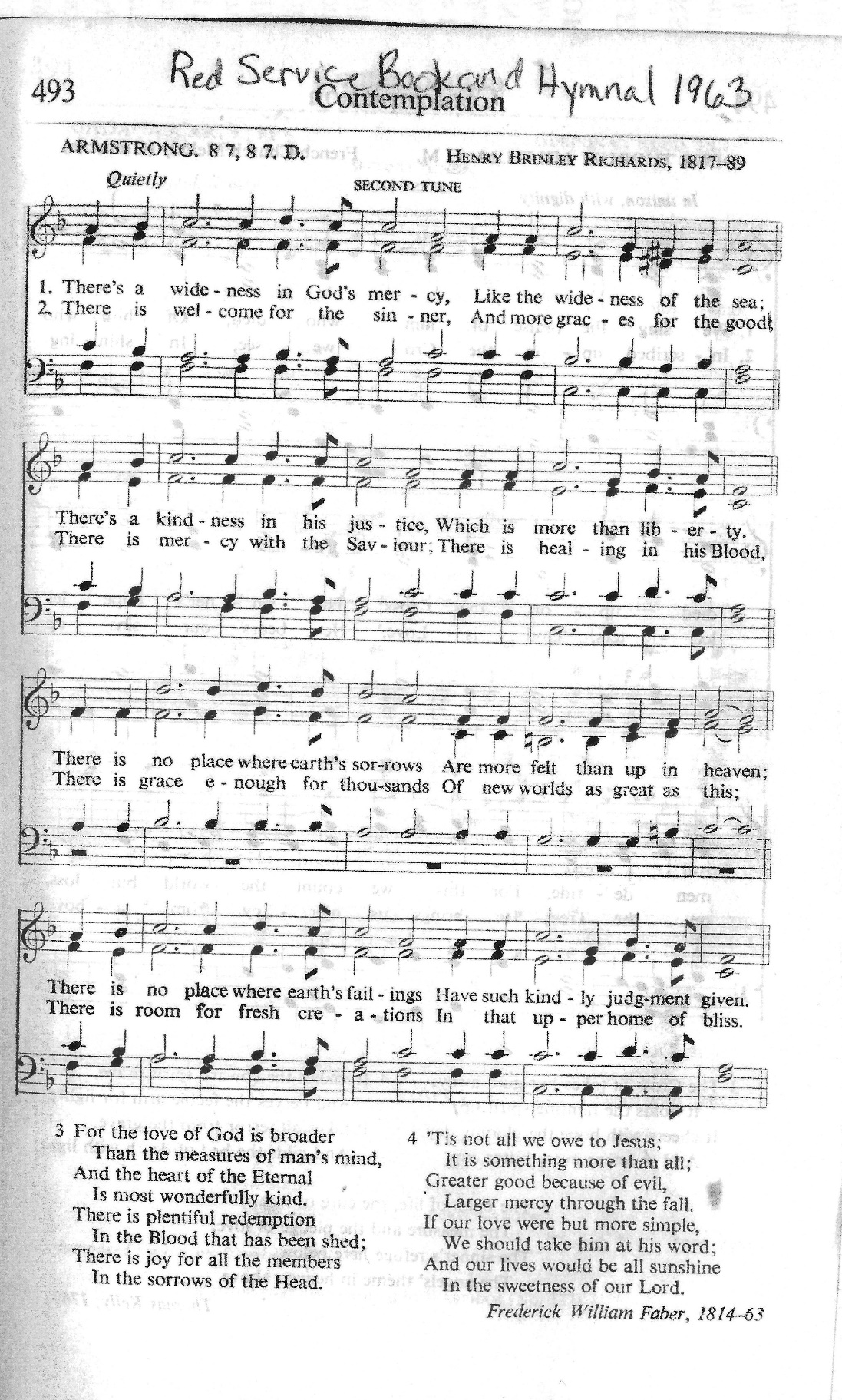

Dismissal P: Go in peace. God is at work in you.
C: Thanks be to God

Announcements
We welcome our visitors and ask that you sign a Visitor Attendance and Holy Communion Card that is located in the pew rack. We ask that cards be returned via the offering plate during the receiving of the offering. We practice “open Communion” here at St. John meaning that all who believe in the “real presence” of Christ are welcomed to receive the Sacrament of Holy Communion. We offer two choices for Holy Communion, wine or grape juice. Those worshipers desiring grape juice are asked at the communion rail to place their right hand over their heart after receiving “The Body of Christ.”

Remember in prayer: Rowan Aldridge, Jim Allen, Christine and Dave Barner, Linda Caris, Agnes Cryder, Don & Helen Delaney, Mary Ellen Doughtery, Joanne Fisher, Dawn Fryer, Dina George, Barb Hoffman, Mick Miller, Bob Moriarity, Elsie Parks in Haven Place, Cora Pelletier, Shane Snyder, and all of our shut-ins.

We also remember in prayer Family Promise; Presiding Bishop Elizabeth Eaton – ELCA; Bishop Craig A. Miller - USS; for our Companion Synods in Liberia and Ansbach-Wurzburg, Germany, and for peace in Ukraine.

We pray for the safety of our military troops around the world including Mark Baier, Isaac Boring, Jade Cordrey, Ben Cramer, Trevor and Nehemiah Eberhart, Patrick Hamlin, Paul Laidacker, Steven Moore, Maddison Myers, Tyler O’Neal, Adam Shaffer, Jeremy and Haley Naugle Sorrell, Richie Speicher, Aaron Stabley, Paul St. James, Kevin Titus, and Jenna White. We also lift up in prayer their families who strive to keep a normalcy in the family and continue on often with added stress.

Thanks to this week’s helpers: Lector –Darlene Bilby; Assisting Ministers—Bill Ely and Ken Dougherty; Children’s Church –Pan Wehler; Head Usher –Shelby Rice; Teller –Deb Heydrich; Bulletin Sponsor – Sue Willits.

Next weeks’ helpers: Lector –Shane Snyder; Assisting Ministers—Gary Johnson, Karen Aucker; Children’s Church –Cathy Eisner; Head Usher –Shelby Rice; Teller –Deb Heydrich; Bulletin Sponsor – Sue Willits.

The flowers are to the glory of God by the Auckers.

The Sanctuary Candle in October is in honor of family birthdays by Agnus Cryder.

The Lutheran Church Women’s Prayer Chain is a vital ministry of St. John Lutheran. Anyone in need of prayers is asked to contact any of the following persons:
Gloria Ely – 570-873-3597 Joyce Braucht - 570-398-2852

This bulletin and more can be found on our church website: www.stjl.org.

Youth Group is meeting Sunday, October 15 after worship in the to go to Carpenter’s farm for a hayride and to pick pumpkins. Come join us!

WOMEN OF THE CHURCH will meet after the worship service next Sunday, October 15. A meeting is also planned for Sunday, November 12.

🌶️ CALLING ALL CHILI LOVERS🌶️ Mark your calendar October 22 Chili cook off ...Our Social for the month, following Worship, will be a Fund Raiser for Pastors Discretionary Fund! We need your help! If you willing to make a crockpot of Chili please let someone on council know! We will be selling bowls of Chili 🌶️ for $5.00, that will include a roll, dessert & drink! (Chicken noodle soup has been added for non-chili eaters) And for $1 you get 5 samples and ballots to vote for your Favorite CHILI! If we have extras will sell takeouts! Hope to see you there!

2023 Lycoming County CROP Walk The annual CROP Walk to support world Hunger is TODAY. October 8, registration and walk begins at 1 pm in front of St. Mark’s Lutheran Church, 142 Market St, Williamsport. Walkers can walk 3, 6, or 9 miles on the River Walk. This is our 45th Walk, and to date, we raised over 1 million dollars to help stop hunger! Last year we raised almost $9,000. 25% of that went to the New Love Center. Help us raise funds to support hunger needs here in our communities. More information can be found at www.crophungerwalk.org/williamsportpa

Seafarer’s Bags are due November 1 (It’s fast approaching!) The bags, list, and directions are on the table in the office. Our very own Pastor Martha McCracken was on the board of Seafarer’s International and served as their president.

IT’S BUDGET TIME!!! Committee chairs please submit your proposed budget for 2024 to Bob Dittmar by Oct 22.

SAVE THE DATE!! Christmas Bazaar will be Saturday, December 9.

Calendar
Sunday, October 8.2023 19th Sunday after Pentecost
8:30 A.M. Adult Sunday School
9:30 a.m. Worship Service with Children’s Church
1:00 p.m. Blessing of the Animals
2:00 p.m. Catechism
Monday, October 9, 2023 10:00 a.m. Bible Study
Wednesday, October 11, 2023 6:30 Choir Rehearsal
Thursday, October 12, 2023 4:00 p.m. Box Packing
Friday, October 13, 2023 9:00 a.m. – 1:00 p.m. Food Distribution
Sunday, October 15, 2023 20th Sunday after Pentecost
8:30 A.M. Adult Sunday School
9:30 a.m. Worship Service with Children’s Church
10:30 a.m. Youth Group Carpenter’s Farm pumpkins and!
10:30 a.m. Women of the Church meeting
