St. John Evangelical Lutheran Church Sunday, July 16, 2023
229 South Broad Street
Jersey Shore, PA 17740 7th Sunday after Pentecost
570-398-1676
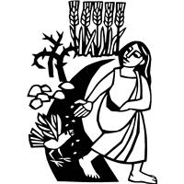
Introduction to the day
God’s word is like the rain that waters the earth and brings forth vegetation. It is also like the sower who scatters seed indiscriminately. Our lives are like seeds sown in the earth. Even from what appears to be little, dormant, or dead, God promises a harvest. At the Lord’s table we are fed with the bread of life, that we may bear fruit in the world.

SHARING OUR JOYS AND CONCERNS

Gathering
The Holy Spirit calls us together as the people of God.

Confession and Forgiveness
The assembly stands. All may make the sign of the cross, the sign that is marked at baptism, as the presiding minister begins.
Blessed be the holy Trinity,☩ one God,
who greets us in this and every season,
whose word never fails,
whose promise is sure. Amen.
Let us confess our sin in the presence of God
and of our neighbors.
Merciful God,
we confess that we have sinned. We have hurt our community.
We have squandered your blessings. We have hoarded your bounty.
In the name of Jesus, forgive us and grant us your mercy.
Silence is kept for reflection.
Righteous God,
we confess that we have sinned. We have failed to be honest.
We have lacked the courage to speak. We have spoken falsely.
In the name of Jesus, forgive us and grant us your mercy.
Silence is kept for reflection.
God is a cup of cold water when we thirst.
God offers boundless grace when we fail.
Claim the gift of God’s mercy:
you are freed and forgiven
in the name of ☩ Jesus Christ. Amen.

Gathering Song: Open Now Thy Gates of Beauty 533

Greeting
P: The grace of our Lord Jesus Christ, the love of God,
and the communion of the Holy Spirit be with you all.
C: And also, with you.

Hymn of PRAISE: Pass It On
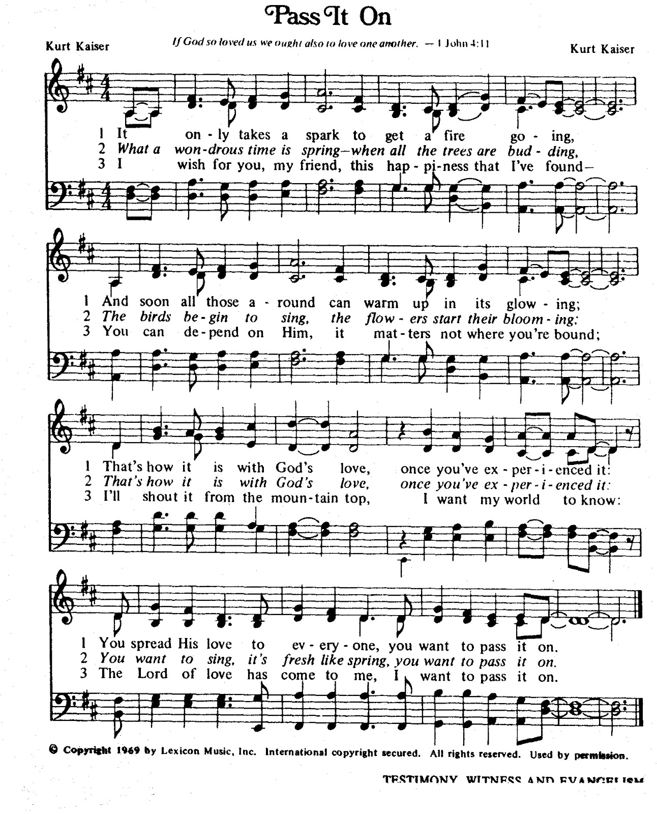

Prayer of the Day
P: Let us pray.
Almighty God, we thank you for planting in us the seed of your word. By your Holy Spirit help us to receive it with joy, live according to it, and grow in faith and hope and love, through Jesus Christ, our Savior and Lord.
Amen.
The assembly is seated.
Word
God speaks to us in scripture reading, preaching, and song.

L: A reading from Isaiah

First Reading: First Reading: Isaiah 55:10-13
God’s word to Israel’s exiles is as sure and effective as never-failing precipitation. Their return to the Holy Land in a new exodus is cheered on by singing mountains and by trees that clap their hands.
¹⁰For as the rain and the snow come down from heaven,
and do not return there until they have watered the earth,
making it bring forth and sprout,
giving seed to the sower and bread to the eater,
¹¹so shall my word be that goes out from my mouth;
it shall not return to me empty,
but it shall accomplish that which I purpose,
and succeed in the thing for which I sent it.
¹²For you shall go out in joy,
and be led back in peace;
the mountains and the hills before you
shall burst into song,
and all the trees of the field shall clap their hands.
¹³Instead of the thorn shall come up the cypress;
instead of the brier shall come up the myrtle;
and it shall be to the Lord for a memorial,
for an everlasting sign that shall not be cut off.

L: The word of the Lord.
C: Thanks be to God.

L Let us read the Psalm responsively by verse

Psalm: Psalm 65:[1-8] 9-13
[ ¹You are to be praised, O |God, in Zion;
to you shall vows |be fulfilled.
²To you, the one |who answers prayer,
to you all |flesh shall come.
³Our sins are strong- er than we are,
but you blot out our transgressions.
⁴Happy are they whom you choose and draw to your courts to dwell there!
They will be satisfied by the beauty of your house, by the holiness of your temple.
⁵Awesome things will you show us in your righteousness, O God of our salvation,
O hope of all the ends of the earth and of the oceans far away.
⁶You make firm the mountains by your power;
you are girded about with might.
⁷You still the roaring of the seas,
the roaring of their waves, and the clamor of the peoples.
⁸Those who dwell at the ends of the earth will tremble at your marvelous signs;
you make the dawn and the dusk to sing for joy.
⁹You visit the earth and water it abundantly; you make it very plenteous; the river of God is full of water.
You prepare the grain, for so you provide for the earth.
¹⁰You drench the furrows and smooth out the ridges;
with heavy rain you soften the ground and bless its increase.
¹¹You crown the year with your goodness,
and your paths overflow with plenty.
¹²May the fields of the wilderness be rich for grazing,
and the hills be clothed with joy.
¹³May the meadows cover themselves with flocks, and the valleys cloak themselves with grain;
let them shout for joy and sing.

L: A reading from Romans

Second Reading: Romans 8:1-11
There is no condemnation for those who live in Christ. God sent Christ to accomplish what the law was unable to do: condemn sin and free us from its death-dealing ways. The Spirit now empowers proper actions and values in our lives and gives us the promise of resurrected life.
¹There is therefore now no condemnation for those who are in Christ Jesus. ²For the law of the Spirit of life in Christ Jesus has set you free from the law of sin and of death. ³For God has done what the law, weakened by the flesh, could not do: by sending his own Son in the likeness of sinful flesh, and to deal with sin, he condemned sin in the flesh, ⁴so that the just requirement of the law might be fulfilled in us, who walk not according to the flesh but according to the Spirit. ⁵For those who live according to the flesh set their minds on the things of the flesh, but those who live according to the Spirit set their minds on the things of the Spirit. ⁶To set the mind on the flesh is death, but to set the mind on the Spirit is life and peace. ⁷For this reason the mind that is set on the flesh is hostile to God; it does not submit to God’s law—indeed it cannot, ⁸and those who are in the flesh cannot please God.
⁹But you are not in the flesh; you are in the Spirit, since the Spirit of God dwells in you. Anyone who does not have the Spirit of Christ does not belong to him. ¹⁰But if Christ is in you, though the body is dead because of sin, the Spirit is life because of righteousness. ¹¹If the Spirit of him who raised Jesus from the dead dwells in you, he who raised Christ from the dead will give life to your mortal bodies also through his Spirit that dwells in you.

L: The word of the Lord.
C: Thanks be to God.
The assembly stands.
Gospel Acclamation p.142
Alleluia Lord to whom shall we go?
You have the words of eternal life. Alleluia, Alleluia.

P: The holy gospel according to Matthew
C: Glory to you, O Lord.

Gospel: Matthew 13:1-9, 18-23
In Matthew’s gospel, both Jesus and his disciples “sow the seed” of God’s word by proclaiming the good news that “the kingdom of heaven is near.” Now, in a memorable parable, Jesus explains why this good news produces different results in those who hear.
¹That same day Jesus went out of the house and sat beside the sea. ²Such great crowds gathered around him that he got into a boat and sat there, while the whole crowd stood on the beach. ³And he told them many things in parables, saying: “Listen! A sower went out to sow. ⁴And as he sowed, some seeds fell on the path, and the birds came and ate them up. ⁵Other seeds fell on rocky ground, where they did not have much soil, and they sprang up quickly, since they had no depth of soil. ⁶But when the sun rose, they were scorched; and since they had no root, they withered away. ⁷Other seeds fell among thorns, and the thorns grew up and choked them. ⁸Other seeds fell on good soil and brought forth grain, some a hundredfold, some sixty, some thirty. ⁹Let anyone with ears listen!”
¹⁸“Hear then the parable of the sower. ¹⁹When anyone hears the word of the kingdom and does not understand it, the evil one comes and snatches away what is sown in the heart; this is what was sown on the path. ²⁰As for what was sown on rocky ground, this is the one who hears the word and immediately receives it with joy; ²¹yet such a person has no root, but endures only for a while, and when trouble or persecution arises on account of the word, that person immediately falls away. ²²As for what was sown among thorns, this is the one who hears the word, but the cares of the world and the lure of wealth choke the word, and it yields nothing. ²³But as for what was sown on good soil, this is the one who hears the word and understands it, who indeed bears fruit and yields, in one case a hundredfold, in another sixty, and in another thirty.”

P: The gospel of the Lord.
C: Praise to you, O Christ.

The assembly is seated.

Sermon Birds, Thorns, and Other Surprising Responses to God’s Word
The assembly stands.
Hymn of the Day: For the Fruit of All Creation 679

Apostles Creed ( p. 105 at the beginning of the hymnal)

Prayers of Intercession
A: Confident that God receives our joys and concerns, let us offer our prayers for the church, those in need, and all of creation.
Guide your church, O God, to sow seeds of forgiveness and righteousness on good soil. Direct your people to proclaim your love in this congregation and throughout the world. Hear us, O God.
C: Your mercy is great.
A: Sustain your creation, O God, by sending favorable weather, causing trees and fields to grow, protecting waterways from pollution, and instilling in all people the need to be good stewards. Hear us, O God.
C: Your mercy is great.
A: Maintain peace among all people, O God, and raise up lawyers to work for justice in the courts, advocates to speak for the downtrodden, and politicians to work on behalf of the common good. Hear us, O God.
C: Your mercy is great.
A: Heal those who are sick, O God (especially). Guide health care workers to care for those who suffer, scientists to conduct lifesaving research, and counselors to care for victims of sexual abuse and exploitation. Hear us, O God.
C: Your mercy is great.
A: Answer the prayers of those gathered in worship, O God. Protect those who travel near and far, accompany visitors to this congregation, and nurture our faith. Hear us, O God.
C: Your mercy is great.
A: We pray for the work of the Evangelical Lutheran Church Africa Mission in south Sudan and the staff at Lutheran Reconciliation Medical Centre as they work hard to provide hope and healing to so many. Hear us O God,
C: Your mercy is great.
Here other intercessions may be offered.
A: Inspire us by the faithful departed, O God, examples of your embodied love, whose confidence in the resurrection guides us in living lives worthy of the gospel. Hear us, O God.
C: Your mercy is great.
P: Into your hands, O God, we commend all for whom we pray, in the name of the one who reconciled all creation to himself, Jesus Christ our Savior.
Amen.

A TIME OF SILENT MEDITATION

Offering Prayer
A: God of field and forest, sea and sky, you are the giver of all good things.
Sustain us with these gifts of your creation, and multiply your graciousness in us,
that the world may be fed with your love, through Jesus Christ, our Savior and Lord.
Amen.

gREAT THANKSGIVING p.144 (in the beginning of the hymnal)
Dialogue
Holy Holy Holy

Thanksgiving at the Table
Words of Institution
Holy, mighty, and merciful Lord,
heaven and earth are full of your glory.
In great love you sent to us Jesus, your Son,
who reached out to heal the sick and suffering,
who preached good news to the poor,
and who, on the cross, opened his arms to all.

In the night in which he was betrayed,
our Lord Jesus took bread, and gave thanks;
broke it, and gave it to his disciples, saying:
Take and eat; this is my body, given for you.
Do this for the remembrance of me.

Again, after supper, he took the cup, gave thanks,
and gave it for all to drink, saying:
This cup is the new covenant in my blood,
shed for you and for all people for the forgiveness of sin.
Do this for the remembrance of me.

Remembering, therefore, his death, resurrection, and ascension,
we await his coming in glory.

Pour out upon us the Spirit of your love, O Lord,
and unite the wills of all who share this heavenly food,
the body and blood of Jesus Christ, our Lord;
to whom, with you and the Holy Spirit,
be all honor and glory, now and forever.
Amen.

THE LORD’S PRAYER P 145 (in the beginning of the hymnal)

Invitation to Communion
P: All people are called to Christ’s table.
Come, eat what is good.

Communion
When giving the bread and cup, the communion ministers say
The body of Christ, given for you.
The blood of Christ, shed for you.
and each person may respond Amen.

Communion Song Lamb of God You Take Away p.146

Song after Communion Jesus, Remember Me
Jesus, remember me when you come into your kingdom.
Jesus, remember me when you come into your kingdom.

Prayer after Communion
A We thank you, generous God, for the refreshment we have received
at your banquet table. Send us now to spread your generosity into all the world,
through the one who is our dearest treasure, Jesus Christ, our Savior and Lord.
Amen.

Sending
God blesses us and sends us in mission to the world.

Blessing The God who calls across the cosmos
and speaks in the smallest seed
☩ bless, keep, and sustain you now and to the end of the age. Amen.

Sending Song: For the Beauty of the Earth 879

Dismissal P: Go in peace. Share the harvest.
C: Thanks be to God.
Announcements
We welcome our visitors and ask that you sign a Visitor Attendance and Holy Communion Card that is located in the pew rack. We ask that cards be returned via the offering plate during the receiving of the offering. We practice “open Communion” here at St. John meaning that all who believe in the “real presence” of Christ are welcomed to receive the Sacrament of Holy Communion. We offer two choices for Holy Communion, wine or grape juice. Those worshipers desiring grape juice are asked at the communion rail to place their right hand over their heart after receiving “The Body of Christ.”

Remember in prayer: Rowan Aldridge, Jim Allen, Christine and Dave Barner, Agnes Cryder, Don & Helen Delaney, Mary Ellen Doughtery, Joanne Fisher, Dina George, Barb Hoffman, Mick Miller, Cora Pelletier, Shane Snyder, and all of our shut-ins.

We also remember in prayer Family Promise; Presiding Bishop Elizabeth Eaton – ELCA; Bishop Craig A. Miller - USS; for our Companion Synods in Liberia and Ansbach-Wurzburg, Germany.

We pray for the safety of our military troops around the world including Mark Baier, Isaac Boring, Jade Cordrey, Ben Cramer, Trevor and Nehemiah Eberhart, Patrick Hamlin, Paul Laidacker, Kenny Leitch, Steven Moore, Maddison Myers, Tyler O’Neal, Adam Shaffer, Jeremy and Haley Naugle Sorrell, Richie Speicher, Aaron Stabley, Paul St. James, Kevin Titus, and Jenna White. We also lift up in prayer their families who strive to keep a normalcy in the family and continue on often with added stress.

Thanks to this weeks’ helpers: Lector –Shane Snyder; Assisting Ministers—Gary Johnson, Karen Aucker; Head Usher –Deb Heydrich; Teller –Kaye Long; Bulletin Sponsor – Betty Allen.

Next week’s helpers: Lector –Deb Heydrich; Assisting—Joyce Braucht and Carl Schaefer; Head Usher –Deb Heydrich; Teller –Kaye Long; Bulletin Sponsor Betty Allen; Flowers –Cynthia Breon.

The flowers are to the glory of God and in honor of Brett and Shelby Rice’s Anniversary!

The Sanctuary Candle in July is given in memory of my husband by Agnes Cryder.

The Lutheran Church Women’s Prayer Chain is a vital ministry of St. John Lutheran. Anyone in need of prayers is asked to contact any of the following persons:
Gloria Ely – 570-873-3597 Joyce Braucht - 570-398-2852

The Pastor’s Discretionary Fund has been depleted as we responded to people in need. If anyone would want to donate to the Pastor’s Discretionary Fund, make your donation to St. John Evangelical Lutheran Church with the memo: Pastor’s Discretionary Fund. Thank you for providing for the needs of people in our community.

We welcome donations to support our missionary in Liberia, Brian Palmer. Two plastic jugs are available in the front and back of the sanctuary for cash donations or write a check to St John Lutheran with a memo to Brian Palmer.
This bulletin and more can be found on our church website: www.stjl.org

MARK YOUR CALENDAR for the LUKE STRONG 125 mile ride on Saturday, September 2 by Parks-Dean Team. Donations are to assist with a handicap bathroom for Luke. Training for the Luke Strong 2023 Ride is officially underway! As always, your prayers, positive energy and support are GREATLY appreciated. Checks can be made out to Luke Antolick Benefit Fund.

VOLUNTEER NEEDED for Habitat for Humanity in August. Information is on the bulletin board.

Calendar
Sunday, July 16, 2023 7th Sunday after Pentecost
9:30 a.m. Worship Service
6:00-7:30 p.m.VBS Registration at Trinity UMC
Monday, July 17, 2023 6:00-8:00 p.m. VBS at Trinity UMC
Tuesday, July 18. 2023 6:00-8:00 p.m. VBS at Trinity UMC
St John does snacks!
Wednesday, July 19,2023 11:30a.m. Fellowship Time at Shore Diner
6:00-8:00 p.m. VBS at Trinity UMC
Thursday, July 20, 2023 6:00-8:00 p.m. VBS at Trinity UMC
Friday, July 21, 2023 5:00 p.m. NA

Sunday, July 23, 2023 6^{89h} Sunday after Pentecost
9:30 a.m. Worship Service

FIESTA Vacation Bible School
WHEN: July 16-20
Open Registration – Sunday from 6-7:30PM
Monday -Thursday 6-8PM (Crafts, music, games, and Bible stories)
AGES: 3yrs old – 5th grade
Come join us!!!!
