St. John Evangelical Lutheran Church Sunday, August 15, 2021
229 South Broad Street 12th Sunday after Pentecost
Jersey Shore, PA 17740
570-398-1676 HYMN SING
Introduction to the day
Wisdom prepares a feast, sets her table, and invites all to come and eat her bread and drink her wine. The first chapter of John’s gospel owes much to the biblical tradition that imagined Wisdom as existing before anything was created and having a role in the work of creation. Christ, the wisdom of God (1 Cor. 1:24), today invites us to eat his flesh and drink his blood. John’s gospel includes no account of the institution of the Lord’s supper, but here we can't help hearing Jesus’ words as an invitation to the meal of bread and wine we share.
SHARING OUR JOYS AND CONCERNS

Prelude How Great Thou Art 856

Gathering
The Holy Spirit calls us together as the people of God.

GATHERING SONG Morning Has Broken 556

Confession and Forgiveness
The assembly stands. All may make the sign of the cross, the sign that is marked at baptism, as the presiding minister begins.

P: Blessed be the holy Trinity,☩ one God,
the God of manna, the God of miracles, the God of mercy.
Amen.
P Drawn to Christ and seeking God’s abundance, let us confess our sin.
Silence is kept for reflection.
C: God, our provider, help us. It is hard to believe there is enough to share.
We question your ways when they differ from the ways of the world in which we live.
We turn to our own understanding rather than trusting in you.
We take offense at your teachings and your ways. Turn us again to you.
Where else can we turn? Share with us the words of eternal life and feed us for life in the world.
Amen.

P: Beloved people of God: in Jesus, the manna from heaven, you are fed and nourished.
By Jesus, the worker of miracles, there is always more than enough.
Through Jesus, ☩ the bread of life, you are shown God’s mercy:
you are forgiven and loved into abundant life. Amen.

Hymn of PRAISE: It is Well 785 verse 1 and 4

Greeting
P: The grace of our Lord Jesus Christ, the love of God,
and the communion of the Holy Spirit be with you all.
C: And also, with you.

Prayer of the Day
P: Let us pray.
Ever-loving God, your Son gives himself as living bread for the life of the world. Fill us with such a knowledge of his presence that we may be strengthened and sustained by his risen life to serve you continually, through Jesus Christ, our Savior and Lord.
Amen.

The assembly is seated.

Word
God speaks to us in scripture reading, preaching, and song.

First Reading: Proverbs 9:1-6
Wisdom is portrayed as a woman who invites people to partake of her banquet. Just as ordinary food is necessary for physical life, Wisdom’s food—insight and understanding—is necessary for fullness of life with God. Partaking of Wisdom’s banquet is the way to life.
¹Wisdom has built her house,
she has hewn her seven pillars.
²She has slaughtered her animals, she has mixed her wine,
she has also set her table.
³She has sent out her servant-girls, she calls
from the highest places in the town,
⁴“You that are simple, turn in here!”
To those without sense she says,
⁵“Come, eat of my bread
and drink of the wine I have mixed.
⁶Lay aside immaturity, and live,
and walk in the way of insight.”

L: The word of the Lord.
C: Thanks be to God,

HYMN IN THE GARDEN

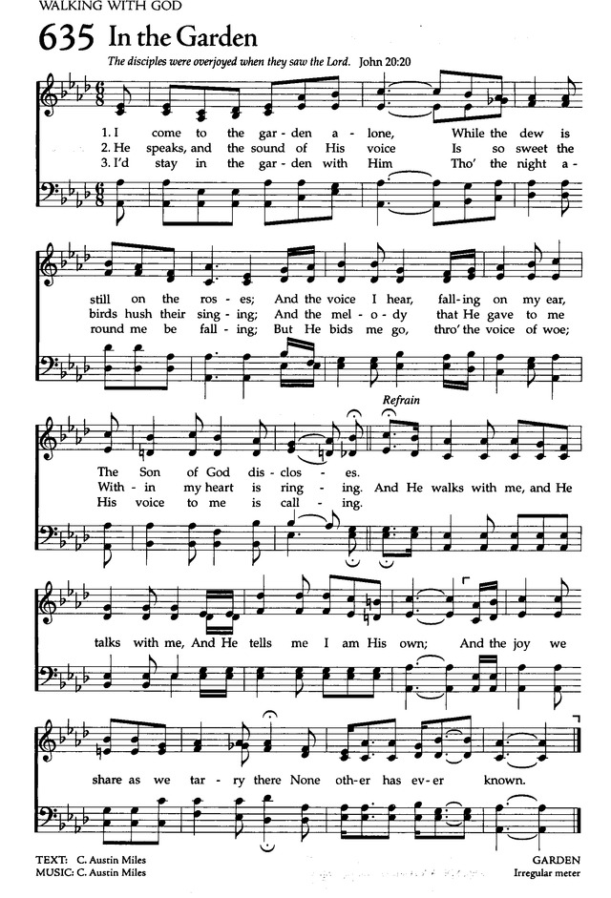

Psalm: Psalm 34:9-14 read responsively

⁹Fear the Lord, you saints of the Lord,
for those who fear the Lord lack nothing.
¹⁰The lions are in want and suffer hunger,
but those who seek the Lord lack nothing that is good.
¹¹Come, children, and listen to me;
I will teach you reverence for the Lord.
¹²Who among you takes pleasure in life
and desires long life to enjoy prosperity?
¹³Keep your tongue from evil
and your lips from lying words.
¹⁴Turn from evil and do good;
seek peace and pursue it.

HYMN Just a Closer Walk 697

Second Reading: Ephesians 5:15-20
True wisdom integrates our new reality in Christ with our Christian fellowship and daily conduct. Because we are filled with the Spirit, Christians regularly rejoice together, give thanks to God for one another, and care for one another. In this way we revere our Lord Jesus Christ.
¹⁵Be careful then how you live, not as unwise people but as wise, ¹⁶making the most of the time, because the days are evil. ¹⁷So do not be foolish, but understand what the will of the Lord is. ¹⁸Do not get drunk with wine, for that is debauchery; but be filled with the Spirit, ¹⁹as you sing psalms and hymns and spiritual songs among yourselves, singing and making melody to the Lord in your hearts, ²⁰giving thanks to God the Father at all times and for everything in the name of our Lord Jesus Christ.

L: The word of the Lord.
C: Thanks be to God.

HYMN Blessed Assurance 638 1 verse

Children’s Sermon –Bread
The assembly stands.
Gospel Acclamation
Stand up Stand up for Jesus
Stand up, stand up for Jesus, ye soldiers of the Cross,
Lift high His royal banner, it must not suffer loss;
From victory unto victory His army shall He lead,
Till every for is vanquished and Christ is Lord indeed.

Gospel: John 6:51-58
In John’s gospel, the feeding of the five thousand leads to extended teaching in which Jesus identifies himself as the true “bread of life.” Finally, in these verses, he makes a connection that would not be understood until after his death, in light of the church’s celebration of holy communion.
[Jesus said,] ⁵¹“I am the living bread that came down from heaven. Whoever eats of this bread will live forever; and the bread that I will give for the life of the world is my flesh.”
⁵²The Jews then disputed among themselves, saying, “How can this man give us his flesh to eat?” ⁵³So Jesus said to them, “Very truly, I tell you, unless you eat the flesh of the Son of Man and drink his blood, you have no life in you. ⁵⁴Those who eat my flesh and drink my blood have eternal life, and I will raise them up on the last day; ⁵⁵for my flesh is true food and my blood is true drink. ⁵⁶Those who eat my flesh and drink my blood abide in me, and I in them. ⁵⁷Just as the living Father sent me, and I live because of the Father, so whoever eats me will live because of me. ⁵⁸This is the bread that came down from heaven, not like that which your ancestors ate, and they died. But the one who eats this bread will live forever.”

P: The gospel of the Lord.
C: Praise to you, O Christ.
The assembly is seated.

HYMN I Love to tell the Story 661

Hymns

Hymn The Old Rugged Cross / On a Hill Far Away
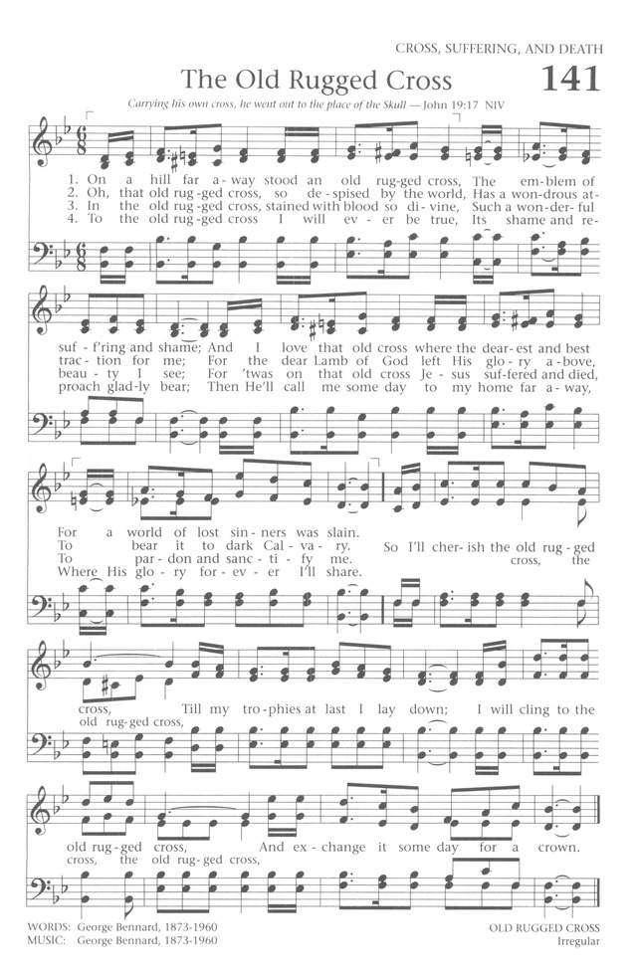
The assembly stands.
HYMN What a Friend We Have in Jesus 742

Prayers of Intercession
A: Rooted in Christ and sustained by the Spirit, we offer our prayers for the church, the world, and all of creation.
A brief silence.
A: God of wisdom, enlighten your church. Guide theologians, biblical scholars, authors, and seminary professors as they seek greater knowledge and invite others into deeper understanding. Teach us to ask faithful questions and open our minds to new ideas. God, in your mercy,
C: hear our prayer.
A: God of creation, mend the earth. Cool warming oceans and preserve melting ice caps. Increase our awareness of changing climate patterns and reveal new approaches to the ecological challenges we face. Shield those in the path of hurricanes or tropical storms (especially). God, in your mercy,
C: hear our prayer.
A: God of all nations, direct our leaders. Grant them courage to lay aside political grudges and renew their determination to address difficult conflicts. Guide them in the work of reconciliation. God, in your mercy,
C: hear our prayer.
A: God of compassion, tend to the wounded. Rescue those tormented by mental illness or mired in addiction. Ease the anxiety of those struggling with dementia. Come quickly to help all who are grieving and all those who suffer (especially). God, in your mercy,
C: hear our prayer.
A: God of beauty, inspire artists. Bless those whose visual and musical gifts enliven this assembly (especially). Bless the creative work of poets, hymn writers, composers, painters, sculptors, and others that enrich our worship and daily life. God, in your mercy,
C: hear our prayer.
Here other intercessions may be offered.
A: God of resurrection, bring us to new life. Give us the living bread from heaven through which we abide in your love, and on the last day raise us with (Mary, mother of Jesus, name/s, and) all the saints to eternal life. God, in your mercy,
C: hear our prayer.
P: We lift these and all our prayers to you, O God, confident in the promise of your saving love; through Jesus Christ our Lord.
Amen.

Our Offerings
The assembly stands.
OFFERATORY Jesus Loves Me 595

Offering Prayer
A. Jesus, Bread of life, you have set this table with your very self, and called us to the feast of plenty. Gather what has been sown among us, and strengthen us in this meal. Make us to be what we receive here, your body for the life of the world. C: Amen.
Dialogue
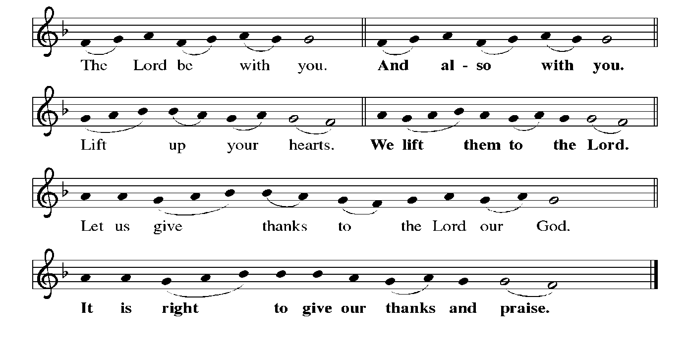
JOYFUL, JOYFUL WE ADORE THEE
Joyful, joyful we adore thee, God of glory, Lord of love!
Hearts unfold like flowers before thee, praising thee, their sun above.
Melt the clouds of sin and sadness, drive the gloom of doubt away.
Giver of immortal gladness, fill us with the light of day.

Words of institution

In the night in which he was betrayed,
our Lord Jesus took bread, and gave thanks;
broke it, and gave it to his disciples, saying:
Take and eat; this is my body, given for you.
Do this for the remembrance of me.

Again, after supper, he took the cup, gave thanks,
and gave it for all to drink, saying:
This cup is the new covenant in my blood,
shed for you and for all people for the forgiveness of sin.
Do this for the remembrance of me.
Lord's Prayer
Our Father, who art in heaven,
hallowed be thy name,
thy kingdom come,
thy will be done,
on earth as it is in heaven.
Give us this day our daily bread;
and forgive us our trespasses,
as we forgive those
who trespass against us;
and lead us not into temptation,
but deliver us from evil.
For thine is the kingdom,
and the power, and the glory,
forever and ever. Amen.

Invitation to Communion
P: Christ has set the table with more than enough for all. Come!

Communion
When giving the bread and cup, the communion ministers say
The body of Christ, given for you.
The blood of Christ, shed for you.
and each person may respond Amen.
COMMUNION SONG Rock of Ages 623
SONGS DURING COMMUNION
On Eagles Wings 787
Borning Cry 732
Song after Communion Jesus, Remember Me
Jesus, remember me when you come into your kingdom.
Jesus, remember me when you come into your kingdom.

Prayer after Communion
Jesus, Bread of life,
you have set this table with your very self,
and called us to the feast of plenty.
Gather what has been sown among us,
and strengthen us in this meal.
Make us to be what we receive here,
your body for the life of the world.
Amen.

Sending
God blesses us and sends us in mission to the world.
Blessing
P: The blessing of God, who provides for us, feeds us, and journeys with us,
☩ be upon you now and forever.
C: Amen.

SENDING SONG Onward Christian Soldiers

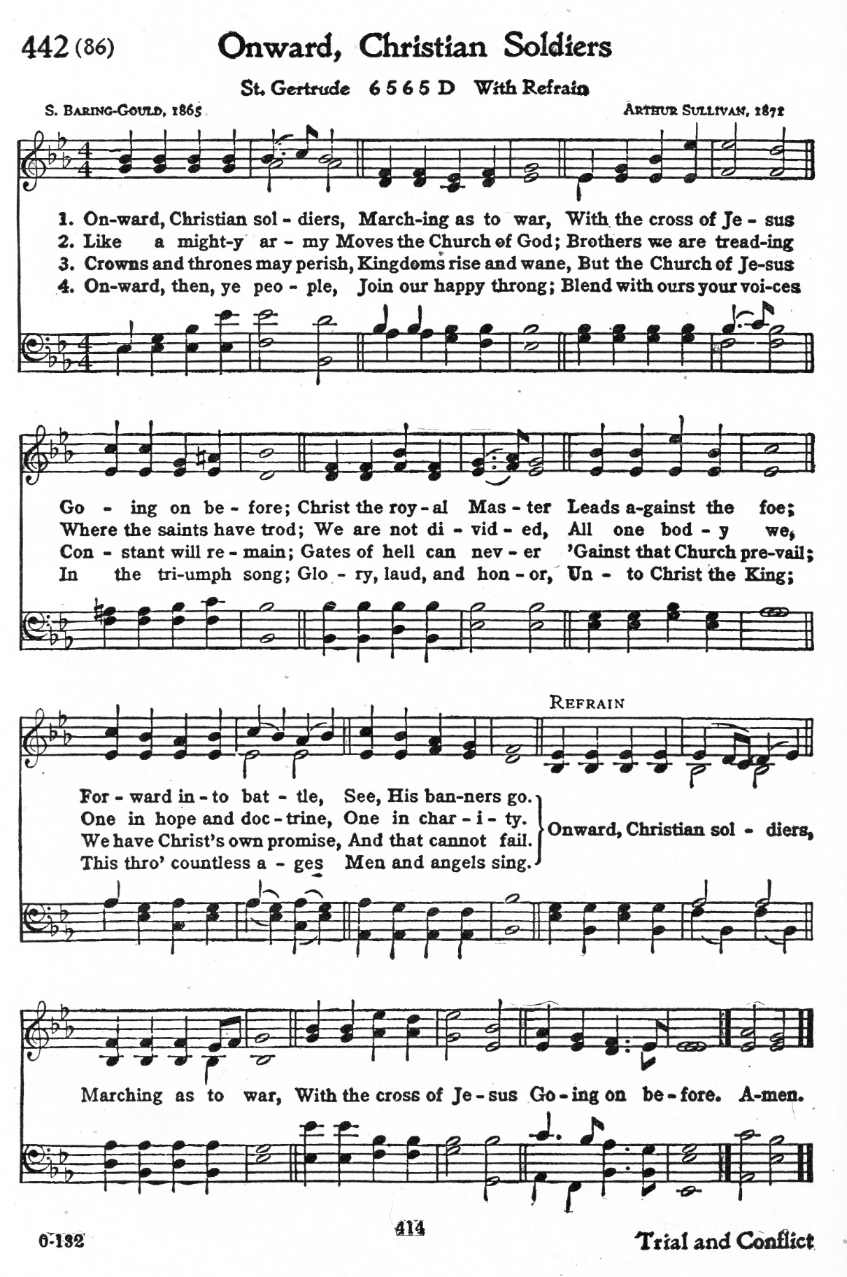

Dismissal
Go in peace. You are the body of Christ.
Thanks be to God.

Postlude

Announcements
We welcome our visitors and ask that you sign a Visitor Attendance and Holy Communion Card that is located in the pew rack. We ask that cards be returned via the offering plate during the receiving of the offering. We practice “open Communion” here at St. John meaning that all who believe in the “real presence” of Christ are welcomed to receive the Sacrament of Holy Communion. We offer two choices for Holy Communion, wine or grape juice. Those worshipers desiring grape juice are asked at the communion rail to place their right hand over their heart after receiving “The Body of Christ”.
Remember in prayer: Luke Antolick, Joanne Fisher, David Kuehl, David Mitchell, Bob and Phyllis Moriarity, Kathy Neal, Ruth Nice, Jean Ann Snyder, Shane Snyder, John Truax, and all of our shut-ins; the safety of our military troops around the world (Mark Baier, Isaac Boring, Jake Cordrey, Richie and Patrick Hamlin, Paul Laidacker, Kenny Leitch, Steven Moore, Maddison Myers, Tyler O’Neal, Adam Shaffer, Aaron Stabley, Paul St. James, Jenna White); Family Promise. Bishop Eaton, our Presiding Bishop; and Bishop Collins, Bishop of the Upper Susquehanna Synod. For our Companion Synod in Liberia and Ansbach-Wurzburg, Germany; and for the New Love Center as it seeks to build a new food hub.
Special Thanks to this week’s helpers: Lector– Shane Snyder; Assisting Ministers –Gary Johnson, Karen Aucker; Acolytes –Grace Welshans Head Usher –Cozette Stolzfus Teller – Max Dincher; Bulletin Sponsor – Dave and Christine Barner; Bread Sponsor – Dean and Gloria Ely
Next week’s helpers: Lector –Deb Heydrich Assisting Ministers – Joyce Braucht, Carl Schaefer; Acolyte –OceAnn Green ; Head Usher - Cozette Stolzfus; Teller-Max Dincher ; Bulletin Sponsor—Dave and Christine Barner; Bread Sponsor – Dean and Gloria Ely . Flowers –Wehler.
The Sanctuary Candle is sponsored by Myrtle Long during the month of August in loving memory of my sister.
The altar flowers are given to the glory of God and the marriage of Nicole Yost and Andrew Scott.

Dear Pastor & Members of St. John,
Thank you for sending me to Camp Mount Luther. I had a wonderful time. I swam, went fishing, went peddleboating, sang songs, built Legos, did crafts, and played games. I saw a bald eagle’s nest and I slept under the stars. It was awesome!
Thank you,
Trenton

Penny and Ken’s Ride for Luke
We invite you to sponsor and support Penny and Ken’s Ride for Luke Antolick on Saturday, September 4 as they ride the Pine Creek Rails to Trails north to Wellsboro Junction and then back to Jersey Shore to support Luke as he continues to undergo treatments and therapy. He has made so much progress thanks to all of you.

The Lutheran Church Women’s Prayer Chain is a vital ministry of St. John Lutheran.
Anyone in need of prayers is asked to contact any of the following persons:
Gloria Ely – 570-873-3597
Sarah Davidson - 570-398-0659
Joyce Braucht - 570-398-2852

Choir resumes Wednesday, September 1, 6:30 p.m. Come and share your joyful voices!
“DAVID” playing at Sight and Sound !!
August 6,2022 -- Children 10 and under $125.00; Adults $190.00. Fare includes bus, play, meal, tip for driver and fund raiser for Luke Antolick. Payments may be made during the course of the year! Thank You! Joyce Braucht.
Giving Plus+ Download the “Giving Plus+” app from your app store for your cell phone. This feature is also available on our web site. Enter your email, make up a password, and walk through the choices to give the church an electronic donation by check or debit/credit card. People were asking if they could give electronically by debit/credit card. Now this feature is available. If you have any questions, contact Pastor or Scott Mitchell.
Give+ Text: Simply send a text message to 570-865-1101 with the amount you would like to contribute (example: 25). Within a few minutes, you’ll be sent a text with a link to register. Click on the link and enter your card holder name and credit or debit card information. Once your registration is complete, you will receive a text verification and a receipt of your donation via email. For future giving, send a text with the amount you wish to give, and it will process automatically! You can even text “repeat” to make it a recurring donation. Give+ Text is one of the fastest, easiest ways to give. We hope you enjoy this new way to share your generosity and we thank you for supporting your church.
“Grab-a-Tab” The youth of St. John would like to ask for donations of little tabs from beverage, soup and dessert cans. It doesn’t matter what color the tab, just grab them and deliver them to the church office. This project will benefit the Ronald McDonald House of Danville. “Grab-a-Tab” program allows people of all ages to join in the effort of providing a “Home-away-from-Home” to children with cancer or other serious illnesses and their families.

THIS WEEK’S EVENTS

Sunday, August 15, 2021 12th Sunday after Pentecost
9:30 a.m. Nave Worship Service
7:00 p.m. NA meeting
Monday, August 16, 2021
PB & J Day
6:00 p.m. Christian Education Meeting
7:00 p.m. Worship and Music Meeting
7:00 p.m. Youth Ministry Meeting
7:30 P.M. NA meeting
Wednesday, August 18, 2021
10:00 a.m. Communion Trinity Episcopal Church

Sunday, August 22, 2021 13th Sunday after Pentecost
9:30 a.m. Nave Blessing of Backpacks, Students and Teachers
7:00 p.m. NA meeting

