St. John Evangelical Lutheran Church Sunday, August 1, 2021
229 South Broad Street 10th Sunday after Pentecost
Jersey Shore, PA 17740
570-398-1676
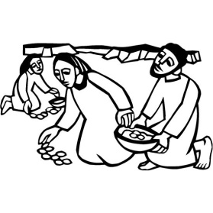

Introduction to the day
Apparently not satisfied by Jesus’ feeding of thousands, some who were there press him for a sign of his power; perhaps it is daily manna they want. As always in John’s gospel when people want a sign, Jesus offers himself. He is the bread come from heaven to give life to the world. He calls us to come to him and believe in him, and through that relationship to know the one who sent him.

SHARING OUR JOYS AND CONCERNS

Prelude

Gathering
The Holy Spirit calls us together as the people of God.

Confession and Forgiveness
The assembly stands. All may make the sign of the cross, the sign that is marked at baptism, as the presiding minister begins.

P: Blessed be the holy Trinity,☩ one God,
the God of manna, the God of miracles, the God of mercy.
Amen.

P: Drawn to Christ and seeking God’s abundance,
let us confess our sin.

Silence is kept for reflection.
C: God, our provider, help us. It is hard to believe there is enough to share. We question your ways when they differ from the ways of the world in which we live. We turn to our own understanding rather than trusting in you. We take offense at your teachings and your ways. Turn us again to you. Where else can we turn? Share with us the words of eternal life
and feed us for life in the world.
Amen.

P: Beloved people of God: in Jesus, the manna from heaven, you are fed and nourished. By Jesus, the worker of miracles, there is always more than enough. Through Jesus, ☩ the bread of life, you are shown God’s mercy: you are forgiven and loved into abundant life.
Amen.

Gathering Song: What Feast of Love 487

Greeting
P: The grace of our Lord Jesus Christ, the love of God,
and the communion of the Holy Spirit be with you all.
C: And also, with you.

Hymn of PRAISE: Blest Be the Tie that Binds 645

Prayer of the Day
P: Let us pray.
O God, eternal goodness, immeasurable love, you place your gifts before us; we eat and are satisfied. Fill us and this world in all its need with the life that comes only from you, through Jesus Christ, our Savior and Lord.
Amen.

The assembly is seated.

Word
God speaks to us in scripture reading, preaching, and song.

First Reading: Exodus 16:2-4, 9-15
A food crisis becomes a faith crisis for the Israelites in the wilderness. The hungry people forget God’s saving work in the exodus, and they wish for the food they had in Egypt. Nevertheless, God miraculously meets their needs, with manna for bread and quail for meat.

²The whole congregation of the Israelites complained against Moses and Aaron in the wilderness. ³The Israelites said to them, “If only we had died by the hand of the Lord in the land of Egypt, when we sat by the fleshpots and ate our fill of bread; for you have brought us out into this wilderness to kill this whole assembly with hunger.”
⁴Then the Lord said to Moses, “I am going to rain bread from heaven for you, and each day the people shall go out and gather enough for that day. In that way I will test them, whether they will follow my instruction or not.”
⁹Then Moses said to Aaron, “Say to the whole congregation of the Israelites, ‘Draw near to the Lord, for he has heard your complaining.’ ” ¹⁰And as Aaron spoke to the whole congregation of the Israelites, they looked toward the wilderness, and the glory of the Lord appeared in the cloud. ¹¹The Lord spoke to Moses and said, ¹²“I have heard the complaining of the Israelites; say to them, ‘At twilight you shall eat meat, and in the morning you shall have your fill of bread; then you shall know that I am the Lord your God.’ ”
¹³In the evening quails came up and covered the camp; and in the morning there was a layer of dew around the camp. ¹⁴When the layer of dew lifted, there on the surface of the wilderness was a fine flaky substance, as fine as frost on the ground. ¹⁵When the Israelites saw it, they said to one another, “What is it?” For they did not know what it was. Moses said to them, “It is the bread that the Lord has given you to eat.”

L: The word of the Lord.
C: Thanks be to God.

Psalm: 78:23-29 read responsively

²³So God commanded the clouds above
and opened the doors of heaven,
²⁴raining down manna upon them to eat
and giving them grain from heaven.
²⁵So mortals ate the bread of angels;
God provided for them food enough.
²⁶The Lord caused the east wind to blow in the heavens
and powerfully led out the south wind,
²⁷raining down flesh upon them like dust
and flying birds like the sand of the seas,
²⁸letting them fall in the midst of the camp
and round about the dwellings.
²⁹So the people ate and | were well filled,
for God gave them | what they craved.

Second Reading: Ephesians 4:1-16
Christians share fundamental unity and diversity. Our unity consists in the one body, one Spirit, one Lord, one faith, one baptism, and one God. Our diversity is expressed in various forms of ministry whose goal is equipping the saints and building up Christ’s one body.

¹I therefore, the prisoner in the Lord, beg you to lead a life worthy of the calling to which you have been called, ²with all humility and gentleness, with patience, bearing with one another in love, ³making every effort to maintain the unity of the Spirit in the bond of peace. ⁴There is one body and one Spirit, just as you were called to the one hope of your calling, ⁵one Lord, one faith, one baptism, ⁶one God and Father of all, who is above all and through all and in all.
⁷But each of us was given grace according to the measure of Christ’s gift. ⁸Therefore it is said,
“When he ascended on high he made captivity itself a captive;
he gave gifts to his people.”
⁹(When it says, “He ascended,” what does it mean but that he had also descended into the lower parts of the earth? ¹⁰He who descended is the same one who ascended far above all the heavens, so that he might fill all things.) ¹¹The gifts he gave were that some would be apostles, some prophets, some evangelists, some pastors and teachers, ¹²to equip the saints for the work of ministry, for building up the body of Christ, ¹³until all of us come to the unity of the faith and of the knowledge of the Son of God, to maturity, to the measure of the full stature of Christ. ¹⁴We must no longer be children, tossed to and fro and blown about by every wind of doctrine, by people’s trickery, by their craftiness in deceitful scheming. ¹⁵But speaking the truth in love, we must grow up in every way into him who is the head, into Christ, ¹⁶from whom the whole body, joined and knit together by every ligament with which it is equipped, as each part is working properly, promotes the body’s growth in building itself up in love.

L: The word of the Lord.
C: Thanks be to God.

Children’s Sermon –Bread

The assembly stands.

Gospel Acclamation
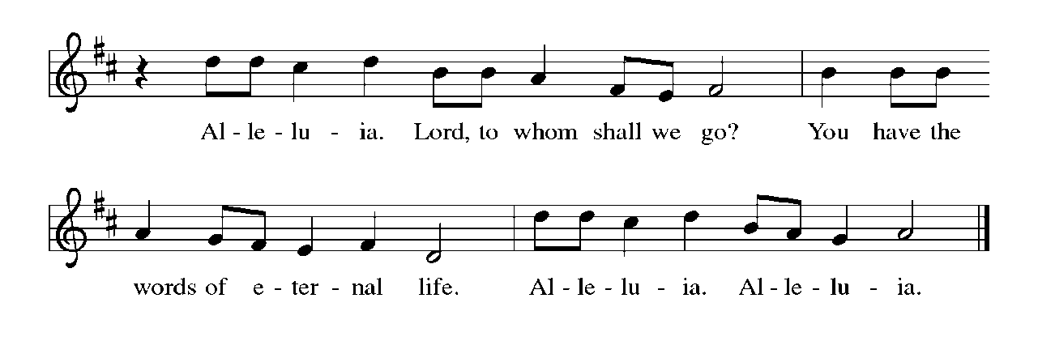

Gospel: John 6:24-35

P: The holy gospel according to John.
C: Glory to you, O Lord.

Many of the five thousand people Jesus fed in the wilderness continued to follow him throughout the countryside. Jesus challenges them to consider the real nature of their quest.

²⁴When the crowd saw that neither Jesus nor his disciples were [beside the sea,] they themselves got into the boats and went to Capernaum looking for Jesus.
²⁵When they found him on the other side of the sea, they said to him, “Rabbi, when did you come here?” ²⁶Jesus answered them, “Very truly, I tell you, you are looking for me, not because you saw signs, but because you ate your fill of the loaves. ²⁷Do not work for the food that perishes, but for the food that endures for eternal life, which the Son of Man will give you. For it is on him that God the Father has set his seal.” ²⁸Then they said to him, “What must we do to perform the works of God?” ²⁹Jesus answered them, “This is the work of God, that you believe in him whom he has sent.” ³⁰So they said to him, “What sign are you going to give us then, so that we may see it and believe you? What work are you performing? ³¹Our ancestors ate the manna in the wilderness; as it is written, ‘He gave them bread from heaven to eat.’ ” ³²Then Jesus said to them, “Very truly, I tell you, it was not Moses who gave you the bread from heaven, but it is my Father who gives you the true bread from heaven. ³³For the bread of God is that which comes down from heaven and gives life to the world.” ³⁴They said to him, “Sir, give us this bread always.” ³⁵Jesus said to them, “I am the bread of life. Whoever comes to me will never be hungry, and whoever believes in me will never be thirsty.”

P: The gospel of the Lord.
C: Praise to you, O Christ.

The assembly is seated.

Sermon More Than a Bagel With Cream Cheese

Hymn of the Day: Guide Me Ever, Great Redeemer 618

Apostles Creed

I believe in God, the Father almighty,
creator of heaven and earth.
I believe in Jesus Christ, God’s only Son, our Lord,
who was conceived by the Holy Spirit,
born of the virgin Mary,
suffered under Pontius Pilate,
was crucified, died, and was buried;
he descended to the dead.
On the third day he rose again;
he ascended into heaven,
he is seated at the right hand of the Father,
and he will come to judge the living and the dead.
I believe in the Holy Spirit,
the holy catholic church,
the communion of saints,
the forgiveness of sins,
the resurrection of the body,
and the life everlasting. Amen.

Prayers of Intercession

A: Rooted in Christ and sustained by the Spirit, we offer our prayers for the church, the world, and all of creation.
A brief silence.
A: You call your church to be the body of Christ. Awaken all the baptized to the gifts you provide for carrying out the work of ministry. Where the church is divided, knit us together and restore the unity of the faith. Hear us, O God.
C: Your mercy is great.
A: You command the clouds above and cause the wind to blow in the heavens. Watch over deserts and wilderness places. Regenerate rainforests, defend species at risk of extinction, and strengthen the work of conservation organizations (especially). Hear us, O God.
C: Your mercy is great.
A: You summon leaders to respond to the needs of your people. Instill those who govern with patience when confronted with grievances and perseverance in seeking what promotes the well-being of the community. Hear us, O God.
C: Your mercy is great.
A: You draw near to those who cry out for help. Feed those who are hungry, reassure those who are despairing, and accompany those who are imprisoned. Rain down the true bread from heaven that gives life to the world. Hear us, O God.
C: Your mercy is great.
A: You receive all who come seeking a sign of grace. Make this congregation a place of hospitality for those accustomed to rejection. To those who have felt excluded here or elsewhere, prepare us to welcome them in the name of Christ. Hear us, O God.
C: Your mercy is great.

Here other intercessions may be offered.
A: You provide food that endures for eternal life. Sustain us each day with the bread of life until we are gathered with (name/s and) all the saints and feast together at your heavenly banquet. Hear us, O God.
C: Your mercy is great.
P: lift these and all our prayers to you, O God, confident in the promise of your saving love; through Jesus Christ our Lord.
Amen.

Our Offerings

OFFERATORY
Create in me a clean heart, O God, and renew a right spirit with me.
Cast me not away from your presence and take not your Holy Spirit from me.
Restore to me the joy of your salvation, and uphold me with your free Spirit.

Offering Prayer
A: Jesus, Bread of life,
you have set this table with your very self,
and called us to the feast of plenty.
Gather what has been sown among us,
and strengthen us in this meal.
Make us to be what we receive here,
your body for the life of the world.
C: Amen.

Dialogue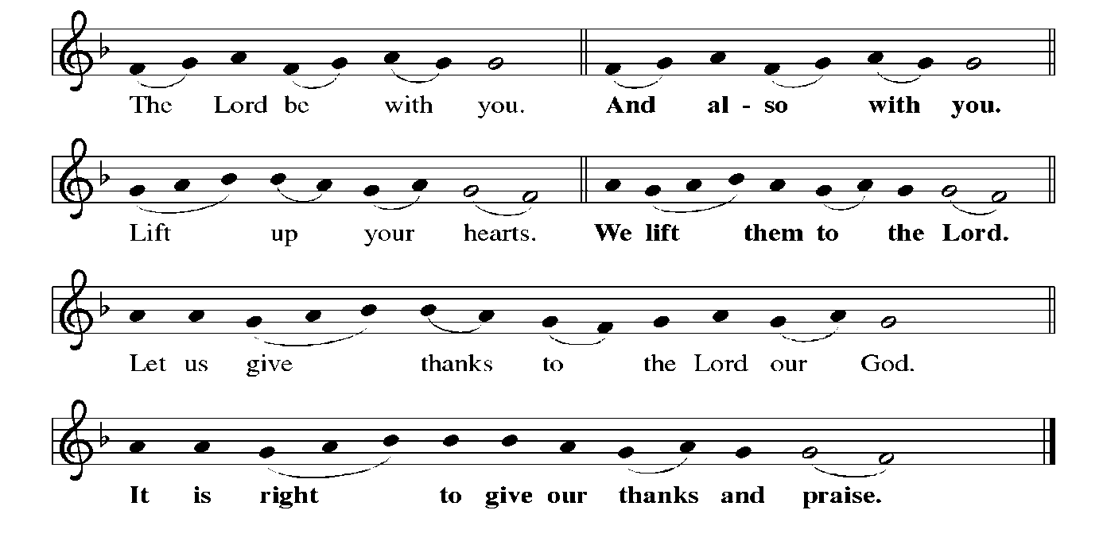

PrefacE By Pastor

HOLY, HOLY, HOLY

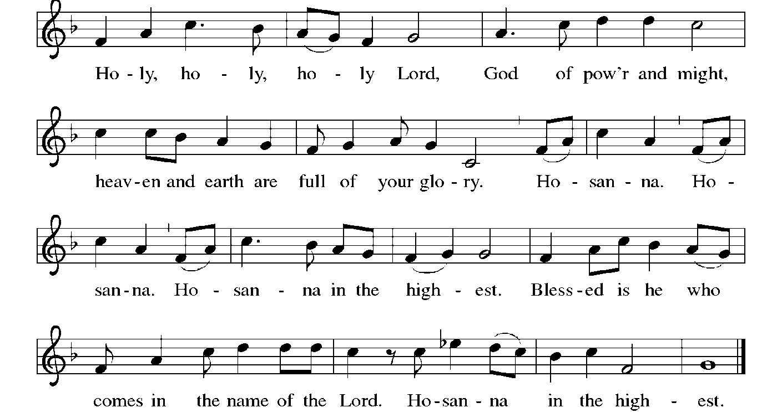

Thanksgiving at the Table
Holy God, holy and mighty, holy and immortal:
you we praise and glorify, you we worship and adore.

You formed the earth from chaos;
you encircled the globe with air;
you created fire for warmth and light;
you nourish the lands with water.
You molded us in your image,
and with mercy higher than the mountains,
with grace deeper than the seas,
you blessed the Israelites and cherished them as your own.

That also we, estranged and dying,
might be adopted to live in your Spirit,
you called to us through the life and death of Jesus.

In the night in which he was betrayed,
our Lord Jesus took bread, and gave thanks;
broke it, and gave it to his disciples, saying:
Take and eat; this is my body, given for you.
Do this for the remembrance of me.

Again, after supper, he took the cup, gave thanks,
and gave it for all to drink, saying:
This cup is the new covenant in my blood,
shed for you and for all people for the forgiveness of sin.
Do this for the remembrance of me.

Together as the body of Christ,
we proclaim the Lord’s death until he comes:
Christ has died.
Christ is risen.
Christ will come again.

With this bread and cup we remember your Son,
the first-born of your new creation.
We remember his life lived for others,
and his death and resurrection, which renews the face of the earth.
We await his coming,
when, with the world made perfect through your wisdom,
all our sins and sorrows will be no more.
Amen. Come, Lord Jesus.

Holy God, holy and merciful one, holy and compassionate,
send upon us and this meal your Holy Spirit,
whose breath revives us for life,
whose fire rouses us to love.
Enfold in your arms all who share this holy food.
Nurture in us the fruits of the Spirit,
that we may be a living tree, sharing your bounty with all the world.
Amen. Come, Holy Spirit.
Holy and benevolent God,

receive our praise and petitions,
as Jesus received the cry of the needy,
and fill us with your blessing,
until, needy no longer and bound to you in love,
we feast forever in the triumph of the Lamb:
through whom all glory and honor is yours, O God, O Living One,
with the Holy Spirit, in your holy church, now and forever.
Amen.

Lord's Prayer
Our Father, who art in heaven,
hallowed be thy name,
thy kingdom come,
thy will be done,
on earth as it is in heaven.
Give us this day our daily bread;
and forgive us our trespasses,
as we forgive those
who trespass against us;
and lead us not into temptation,
but deliver us from evil.
For thine is the kingdom,
and the power, and the glory,
forever and ever. Amen.

Invitation to Communion
P: Christ has set the table with more than enough for all. Come!

Communion

When giving the bread and cup, the communion ministers say
The body of Christ, given for you.
The blood of Christ, shed for you.
and each person may respond Amen.

Communion Song
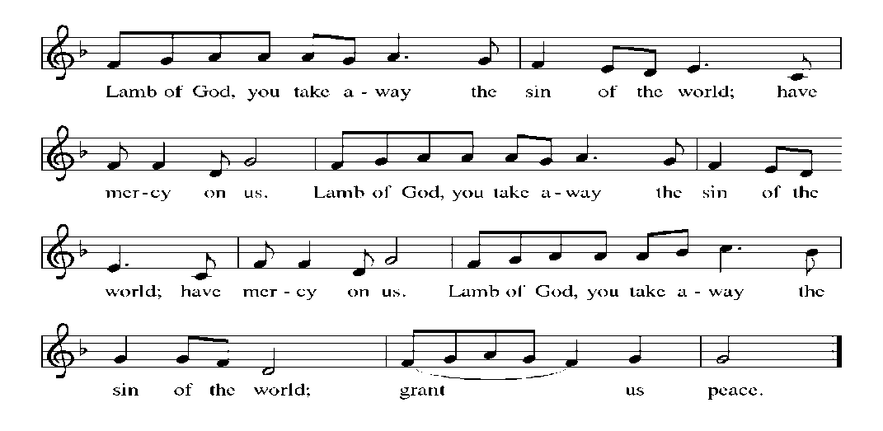

Song after Communion Jesus, Remember Me
Jesus, remember me when you come into your kingdom.
Jesus, remember me when you come into your kingdom.

Prayer after Communion
A: Jesus, Bread of life, we have received from your table more than we could ever ask.
As you have nourished us in this meal, now strengthen us to love the world with your own life.
In your name we pray. C: Amen.

Sending
God blesses us and sends us in mission to the world.

Blessing
P: The blessing of God, who provides for us, feeds us, and journeys with us,
☩ be upon you now and forever. C: Amen.

Sending Song: Son of God, Eternal Savior 655

Dismissal
P: Go in peace. You are the body of Christ.
C: Thanks be to God.

Postlude
Announcements

We welcome our visitors and ask that you sign a Visitor Attendance and Holy Communion Card that is located in the pew rack. We ask that cards be returned via the offering plate during the receiving of the offering. We practice “open Communion” here at St. John meaning that all who believe in the “real presence” of Christ are welcomed to receive the Sacrament of Holy Communion. We offer two choices for Holy Communion, wine or grape juice. Those worshipers desiring grape juice are asked at the communion rail to place their right hand over their heart after receiving “The Body of Christ”.

Remember in prayer: Luke Antolick, David Mitchell, Bob and Phyllis Moriarity, Kathy Neal, Ruth Nice, Jean Ann Snyder, Shane Snyder, John Truax, and all of our shut-ins; the safety of our military troops around the world (Mark Baier, Isaac Boring, Jake Cordrey, Richie and Patrick Hamlin, Paul Laidacker, Kenny Leitch, Steven Moore, Maddison Myers, Tyler O’Neal, Adam Shaffer, Aaron Stabley, Paul St. James, Jenna White); Family Promise. Bishop Eaton, our Presiding Bishop; and Bishop Collins, Bishop of the Upper Susquehanna Synod. For our Companion Synod in Liberia and Ansbach-Wurzburg, Germany; and for the New Love Center as it seeks to build a new food hub.

Special Thanks to this week’s helpers: Lector–Kathy Brundick; Assisting Ministers –Deb Heydrich and Ron Brundick ; Acolytes –Harlee Kastner; Head Usher –Teller –Bulletin Sponsor – Jean Ann Snyder; Bread Sponsor –Dean and Gloria Ely

Next week’s helpers: Lector – Darlene Bilby; Assisting Ministers – Bill Ely, Jr and Ken Doughtery; Acolyte – Ethan Aldridge; Head Usher -; Teller- ; Bulletin Sponsor need volunteers; Bread Sponsor – Dean and Gloria Ely .

The Sanctuary Candle is sponsored by Myrtle Long during the month of August in loving memory of her sister.

The altar flowers are given in loving memory of loved ones by Dean and Barb Hoffman.

We extend our sympathies to the family of Ginny Moffitt who died at her residence on Thursday, July 8, 2021. A celebration of her life will occur on Saturday, August 14, 11:30 am, at St. John Lutheran.

We wish to thank our church family for the beautiful cards and words of comfort we received upon the passing of our mother, Virginia Moffitt. Kathy and Ron Brundick and the Moffitt family.

The Lutheran Church Women’s Prayer Chain is a vital ministry of St. John Lutheran.
Anyone in need of prayers is asked to contact any of the following persons:
Gloria Ely – 570-873-3597
Sarah Davidson - 570-398-0659
Joyce Braucht - 570-398-2852

Vacation Bible School - Breakout
This year our Jersey Shore community Bible School will be held at First United Methodist Church, Main St., JS for three days this year, August 10, 11 and 12 from 6:00 p.m. - 8:00 p.m.
Registration will begin on Tuesday, August 10 at 5:30 p.m. Registration forms are available. This event is for all children ages 3 through completing 5th grade.

Giving Plus+ Download the “Giving Plus+” app from your app store for your cell phone. This feature is also available on our web site. Enter your email, make up a password, and walk through the choices to give the church an electronic donation by check or debit/credit card. People were asking if they could give electronically by debit/credit card. Now this feature is available. If you have any questions, contact Pastor or Scott Mitchell.

Give+ Text: Simply send a text message to 570-865-1101 with the amount you would like to contribute (example: 25). Within a few minutes, you’ll be sent a text with a link to register. Click on the link and enter your card holder name and credit or debit card information. Once your registration is complete, you will receive a text verification and a receipt of your donation via email. For future giving, send a text with the amount you wish to give, and it will process automatically! You can even text “repeat” to make it a recurring donation. Give+ Text is one of the fastest, easiest ways to give. We hope you enjoy this new way to share your generosity and we thank you for supporting your church.

THIS WEEK’S EVENTS

Sunday, August 1, 2021 10th Sunday after Pentecost
9:30 a.m. Nave Worship Service
7:00 p.m. NA meeting
Monday, August 2, 2021
7:30 P.M. NA meeting
Tuesday, August 3, 2021
7:00 p.m. Council Meeting
Wednesday, August 4, 2021
10:00 a.m. Communion Trinity Episcopal Church
7:00 p.m. NA Meeting

Sunday, August 8, 2021 11th Sunday after Pentecost
9:30 a.m. Nave Worship Service
7:00 p.m. NA meeting

