St. John Evangelical Lutheran Church Sunday, August 8, 2021
229 South Broad Street 11th Sunday after Pentecost
Jersey Shore, PA 17740
570-398-1676

Introduction to the day
Jesus says that the bread he gives for the life of the world is his flesh, and whoever eats this bread has eternal life now and will be raised on the last day. In Ephesians Paul tells us what this life Jesus gives us looks like, this life we live as those marked with the seal of the Holy Spirit in baptism. We live in love, as Christ loved us and gave himself up for us. The whole purpose of life is giving yourself for the other.

SHARING OUR JOYS AND CONCERNS

Prelude

Gathering
The Holy Spirit calls us together as the people of God.

Confession and Forgiveness
The assembly stands. All may make the sign of the cross, the sign that is marked at baptism, as the presiding minister begins.

P: Blessed be the holy Trinity,☩ one God,
the God of manna, the God of miracles, the God of mercy.
Amen.

P: Drawn to Christ and seeking God’s abundance,
let us confess our sin.

Silence is kept for reflection.
C: God, our provider, help us. It is hard to believe there is enough to share.
We question your ways when they differ from the ways of the world in which we live. We turn to our own understanding rather than trusting in you. We take offense at your teachings and your ways. Turn us again to you. Where else can we turn? Share with us the words of eternal life and feed us for life in the world.
Amen.

P: Beloved people of God: in Jesus, the manna from heaven, you are fed and nourished. By Jesus, the worker of miracles, there is always more than enough. Through Jesus, ☩ the bread of life, you are shown God’s mercy: you are forgiven and loved into abundant life. Amen.
Gathering Song: Oh Jesus, Joy of Loving Hearts 658

Greeting
P: The grace of our Lord Jesus Christ, the love of God,
and the communion of the Holy Spirit be with you all.
C: And also, with you.

Hymn of PRAISE: Baptized in Water 456

Prayer of the Day
P: Let us pray.
Gracious God, your blessed Son came down from heaven to be the true bread that gives life to the world. Give us this bread always, that he may live in us and we in him, and that, strengthened by this food, we may live as his body in the world, through Jesus Christ, our Savior and Lord
Amen.

The assembly is seated.

Word
God speaks to us in scripture reading, preaching, and song.

First Reading:
First Kings Chapter 18 describes the contest between Elijah and the prophets of Baal. The contest proves that the Lord is God, and afterward Elijah orders the killing of the Baal prophets. Angered by the deaths of her prophets, Queen Jezebel threatens to kill Elijah. This reading finds Elijah fleeing, fatigued, and in utter despair.

1 Kings 19:4-8
⁴[Elijah] went a day’s journey into the wilderness, and came and sat down under a solitary broom tree. He asked that he might die: “It is enough; now, O Lord, take away my life, for I am no better than my ancestors.”⁵Then he lay down under the broom tree and fell asleep. Suddenly an angel touched him and said to him, “Get up and eat.” ⁶He looked, and there at his head was a cake baked on hot stones, and a jar of water. He ate and drank, and lay down again. ⁷The angel of the Lord came a second time, touched him, and said, “Get up and eat, otherwise the journey will be too much for you.” ⁸He got up, and ate and drank; then he went in the strength of that food forty days and forty nights to Horeb the mount of God.

L: The word of the Lord.
C: Thanks be to God.

Psalm: 34:1-8 read responsively Taste and see that the Lord is good.

¹I will bless the Lord at all times;
the praise of God shall ever be in my mouth.
²I will glory in the Lord;
let the lowly hear and rejoice.
³Proclaim with me the greatness of the Lord;
let us exalt God’s name together.
⁴I sought the Lord, who answered me
and delivered me from all my terrors.
⁵Look upon the Lord and be radiant,
and let not your faces be ashamed.
⁶I called in my affliction, and the Lord heard me
and saved me from all my troubles.
⁷The angel of the Lord encamps around those who fear the Lord
and de livers them.
⁸Taste and see that the LORD is good;
happy are they who take refuge in God!

Second Reading: Ephesians 4:25--5:2
Christians are called to be imitators of God. This does not mean Christians are perfect. Rather, the Spirit is at work in our lives so that our actions and attitudes genuinely reflect the love and forgiveness we have received through Christ and his death.

²⁵So then, putting away falsehood, let all of us speak the truth to our neighbors, for we are members of one another. ²⁶Be angry but do not sin; do not let the sun go down on your anger, ²⁷and do not make room for the devil. ²⁸Thieves must give up stealing; rather let them labor and work honestly with their own hands, so as to have something to share with the needy. ²⁹Let no evil talk come out of your mouths, but only what is useful for building up, as there is need, so that your words may give grace to those who hear. ³⁰And do not grieve the Holy Spirit of God, with which you were marked with a seal for the day of redemption. ³¹Put away from you all bitterness and wrath and anger and wrangling and slander, together with all malice, ³²and be kind to one another, tenderhearted, forgiving one another, as God in Christ has forgiven you. ^{5:1}Therefore be imitators of God, as beloved children, ²and live in love, as Christ loved us and gave himself up for us, a fragrant offering and sacrifice to God.

L: The word of the Lord.
C: Thanks be to God.

Children’s Sermon –Bread

The assembly stands.

Gospel Acclamation
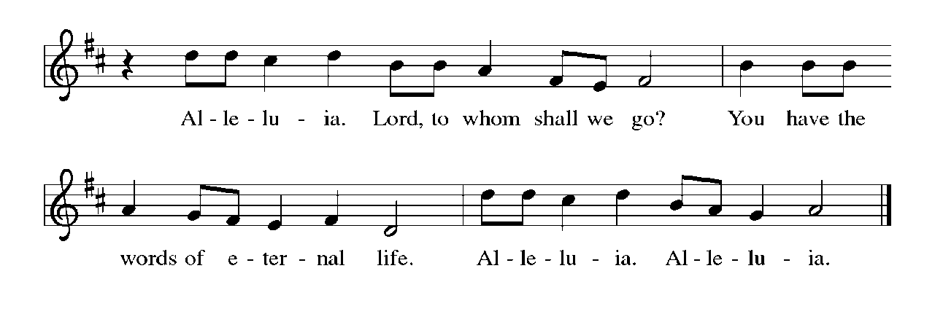

Gospel: John 6:35,41-51 After feeding more than five thousand people in the wilderness, Jesus teaches them regarding the true significance of this remarkable sign.

P: The holy gospel according to John.
C: Glory to you, O Lord.

³⁵Jesus said to [the crowd,] “I am the bread of life. Whoever comes to me will never be hungry, and whoever believes in me will never be thirsty. ⁴¹Then the Jews began to complain about him because he said, “I am the bread that came down from heaven.” ⁴²They were saying, “Is not this Jesus, the son of Joseph, whose father and mother we know? How can he now say, ‘I have come down from heaven’?” ⁴³Jesus answered them, “Do not complain among yourselves. ⁴⁴No one can come to me unless drawn by the Father who sent me; and I will raise that person up on the last day. ⁴⁵It is written in the prophets, ‘And they shall all be taught by God.’ Everyone who has heard and learned from the Father comes to me. ⁴⁶Not that anyone has seen the Father except the one who is from God; he has seen the Father. ⁴⁷Very truly, I tell you, whoever believes has eternal life. ⁴⁸I am the bread of life. ⁴⁹Your ancestors ate the manna in the wilderness, and they died. ⁵⁰This is the bread that comes down from heaven, so that one may eat of it and not die. ⁵¹I am the living bread that came down from heaven. Whoever eats of this bread will live forever; and the bread that I will give for the life of the world is my flesh.”

P: The gospel of the Lord.
C: Praise to you, O Christ.

The assembly is seated.

Sermon

Hymn of the Day: O Living Bread from Heaven 542

Apostles Creed

I believe in God, the Father almighty,
creator of heaven and earth.
I believe in Jesus Christ, God’s only Son, our Lord,
who was conceived by the Holy Spirit,
born of the virgin Mary,
suffered under Pontius Pilate,
was crucified, died, and was buried;
he descended to the dead.
On the third day he rose again;
he ascended into heaven,
he is seated at the right hand of the Father,
and he will come to judge the living and the dead.
I believe in the Holy Spirit,
the holy catholic church,
the communion of saints,
the forgiveness of sins,
the resurrection of the body,
and the life everlasting. Amen.

Prayers of Intercession

A: Rooted in Christ and sustained by the Spirit, we offer our prayers for the church, the world, and all of creation.
A brief silence.
A: For the church of Christ in all its diverse forms. For mission developers, new mission starts, and all communities of faith exploring new models of ministry for the sake of the gospel. For congregations facing difficult decisions about their future. God, in your mercy,

C: hear our prayer.

A: For the health and well-being of creation. For shade trees that provide refuge from the hot summer sun. For lakes, rivers, and oceans contaminated by pollution and all who lack clean water. God, in your mercy,

C: hear our prayer.

A: For those called to positions of authority in our legal system, we pray. For judges, lawyers, law clerks, and court employees who ensure the fair administration of justice. For corrections officers and prison chaplains, that they would deal mercifully with those who are incarcerated. God, in your mercy,

C: hear our prayer.

A: For all who cry out to you in their affliction. For exiles, refugees, and others who face long and difficult journeys, uncertain about the future. For all who mourn the death of a loved one. For all who are sick (especially). God, in your mercy,

C: hear our prayer.

A: For this assembly gathered around your table, we pray. For those among us who bake bread and prepare the vessels for our communion celebration. For those who bring the food from this table to those who are homebound or hospitalized. God, in your mercy,

C: hear our prayer.
Here other intercessions may be offered.
A: For those who have been raised to eternal life, we give thanks. With (Dominic, name/s, and) all the saints we praise you for the bread of life that keeps us in your love forever. God, in your mercy,

C: hear our prayer.

P: We lift these and all our prayers to you, O God, confident in the promise of your saving love; through Jesus Christ our Lord.
Amen.

Our Offerings

OFFERATORY
Create in me a clean heart, O God, and renew a right spirit with me.
Cast me not away from your presence and take not your Holy Spirit from me.
Restore to me the joy of your salvation, and uphold me with your free Spirit.

Offering Prayer
Jesus, Bread of life, you have set this table with your very self,
and called us to the feast of plenty. Gather what has been sown among us,
and strengthen us in this meal. Make us to be what we receive here,
your body for the life of the world.
Amen.

Dialogue
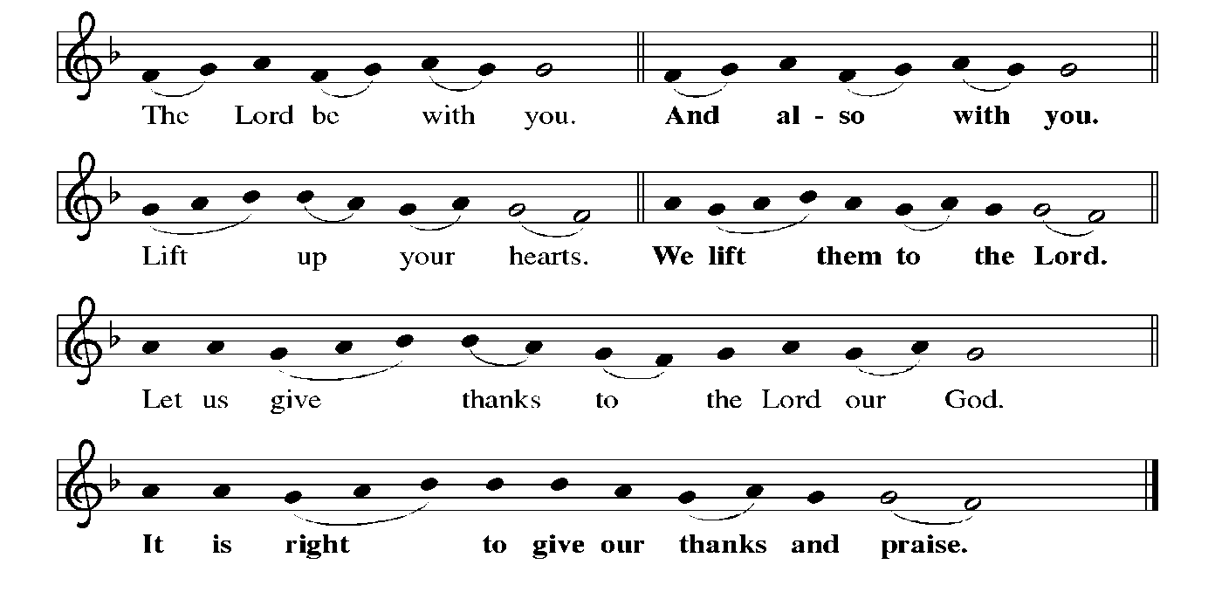

PrefacE By Pastor

HOLY, HOLY, HOLY
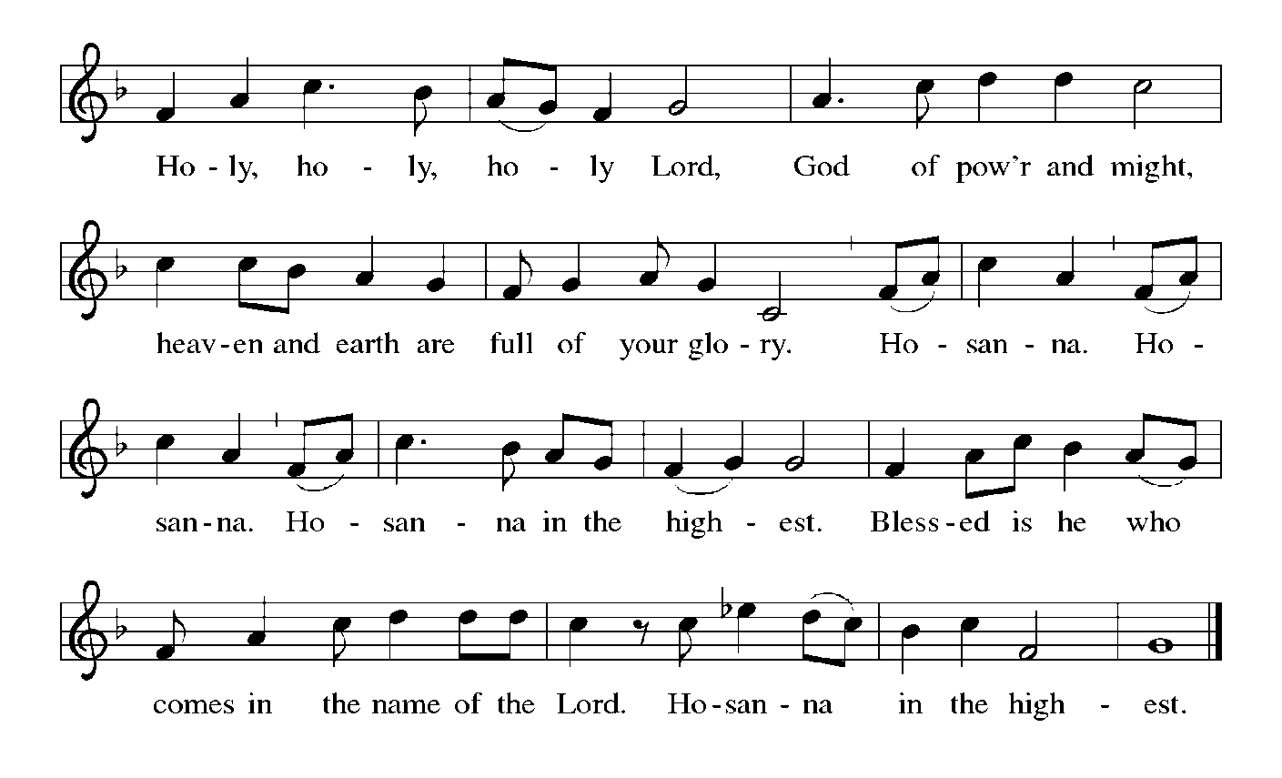

Thanksgiving at the Table
Holy God, holy and mighty, holy and immortal:
you we praise and glorify you, we worship and adore.

You formed the earth from chaos;
you encircled the globe with air;
you created fire for warmth and light;
you nourish the lands with water.
You molded us in your image,
and with mercy higher than the mountains,
with grace deeper than the seas,
you blessed the Israelites and cherished them as your own.

That also we, estranged and dying,
might be adopted to live in your Spirit,
you called to us through the life and death of Jesus.

In the night in which he was betrayed,
our Lord Jesus took bread, and gave thanks;
broke it, and gave it to his disciples, saying:
Take and eat; this is my body, given for you.
Do this for the remembrance of me.

Again, after supper, he took the cup, gave thanks,
and gave it for all to drink, saying:
This cup is the new covenant in my blood,
shed for you and for all people for the forgiveness of sin.
Do this for the remembrance of me.

Together as the body of Christ,
we proclaim the Lord’s death until he comes:
Christ has died.
Christ is risen.
Christ will come again.

With this bread and cup we remember your Son,
the first-born of your new creation.
We remember his life lived for others,
and his death and resurrection, which renews the face of the earth.
We await his coming,
when, with the world made perfect through your wisdom,
all our sins and sorrows will be no more.
Amen. Come, Lord Jesus.

Holy God, holy and merciful one, holy and compassionate,
send upon us and this meal your Holy Spirit,
whose breath revives us for life,
whose fire rouses us to love.
Enfold in your arms all who share this holy food.
Nurture in us the fruits of the Spirit,
that we may be a living tree, sharing your bounty with all the world.
Amen. Come, Holy Spirit.

Holy and benevolent God,
receive our praise and petitions,
as Jesus received the cry of the needy,
and fill us with your blessing,
until, needy no longer and bound to you in love,
we feast forever in the triumph of the Lamb:
through whom all glory and honor is yours, O God, O Living One,
with the Holy Spirit, in your holy church, now and forever.
Amen.

Lord's Prayer
Our Father, who art in heaven,
hallowed be thy name,
thy kingdom come,
thy will be done,
on earth as it is in heaven.
Give us this day our daily bread;
and forgive us our trespasses,
as we forgive those
who trespass against us;
and lead us not into temptation,
but deliver us from evil.
For thine is the kingdom,
and the power, and the glory,
forever and ever. Amen.

Invitation to Communion
P: Christ has set the table with more than enough for all. Come!

Communion
When giving the bread and cup, the communion ministers say
The body of Christ, given for you.
The blood of Christ, shed for you.
and each person may respond Amen.

Communion Song
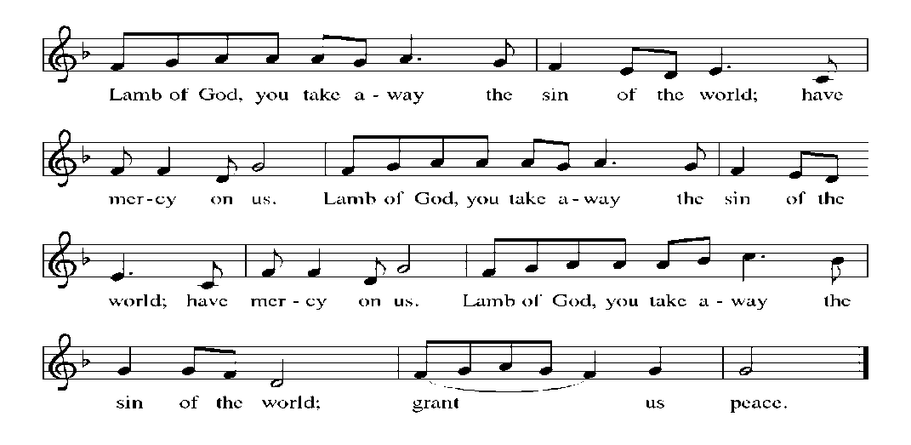

Song after Communion Jesus, Remember Me
Jesus, remember me when you come into your kingdom.
Jesus, remember me when you come into your kingdom.

Prayer after Communion
A: Jesus, Bread of life, we have received from your table
more than we could ever ask.
As you have nourished us in this meal,
now strengthen us to love the world with your own life.
In your name we pray. C: Amen.
Sending

God blesses us and sends us in mission to the world.

Blessing
P: The blessing of God, who provides for us, feeds us, and journeys with us,
☩ be upon you now and forever.
C: Amen.

Sending Song: Be Thou My Vision 793

Dismissal
P: Go in peace. You are the body of Christ.
C: Thanks be to God.

Postlude

Announcements

We welcome our visitors and ask that you sign a Visitor Attendance and Holy Communion Card that is located in the pew rack. We ask that cards be returned via the offering plate during the receiving of the offering. We practice “open Communion” here at St. John meaning that all who believe in the “real presence” of Christ are welcomed to receive the Sacrament of Holy Communion. We offer two choices for Holy Communion, wine or grape juice. Those worshipers desiring grape juice are asked at the communion rail to place their right hand over their heart after receiving “The Body of Christ”.

Remember in prayer: Luke Antolick, David Kuehl, David Mitchell, Bob and Phyllis Moriarity, Kathy Neal, Ruth Nice, Jean Ann Snyder, Shane Snyder, John Truax, and all of our shut-ins; the safety of our military troops around the world (Mark Baier, Isaac Boring, Jake Cordrey, Richie and Patrick Hamlin, Paul Laidacker, Kenny Leitch, Steven Moore, Maddison Myers, Tyler O’Neal, Adam Shaffer, Aaron Stabley, Paul St. James, Jenna White); Family Promise. Bishop Eaton, our Presiding Bishop; and Bishop Collins, Bishop of the Upper Susquehanna Synod. For our Companion Synod in Liberia and Ansbach-Wurzburg, Germany; and for the New Love Center as it seeks to build a new food hub.

Special Thanks to this week’s helpers :Lector –Darlene Bilby Assisting Ministers – Bill Ely, Jr., Ken Dougherty; Acolyte – Ethan Aldridge ; Head Usher - Cozette Stolzfus; Teller-Max Dincher ; Bulletin Sponsor need volunteers; Bread Sponsor – Dean and Gloria Ely .

Next week’s helpers: Lector– Shane Snyder; Assisting Ministers –Gary Johnson, Karen Aucker; Acolytes –Grace Welshans Head Usher –Cozette Stolzfus Teller – Max Dincher; Bulletin Sponsor - need volunteers; Bread Sponsor – Dean and Gloria Ely.

The Sanctuary Candle is sponsored by Myrtle Long during the month of August in loving memory of my sister.
The altar flowers are given to the glory of God and in appreciation of our music makers, Becky and Kaye, with love by their church.

Thank you so much for all the prayers, cards, and caring shown to us during such a difficult time. Special thanks to Pastor, Karen, and the Women of the Church!
Dave and Christine Barner

Penny and Ken’s Ride for Luke
We invite you to sponsor and support Penny and Ken’s Ride for Luke Antolick on Saturday, September 4 as they ride the Pine Creek Rails to Trails north to Wellsboro Junction and then back to Jersey Shore to support Luke as he continues to undergo treatments and therapy. He has made so much progress thanks to all of you.

The Lutheran Church Women’s Prayer Chain is a vital ministry of St. John Lutheran.
Anyone in need of prayers is asked to contact any of the following persons:
Gloria Ely – 570-873-3597
Sarah Davidson - 570-398-0659
Joyce Braucht - 570-398-2852

Vacation Bible School - Breakout
This year our Jersey Shore community Bible School will be held at First United Methodist Church, Main St., JS for three days this year, August 10, 11 and 12 from 6:00 p.m. - 8:00 p.m.
Registration will begin on Tuesday, August 10 at 5:30 p.m. Registration forms are available. This event is for all children ages 3 through completing 5th grade.

Choir resumes Wednesday, September 1, 6:30 p.m. Come and share your joyful voices!

“DAVID” playing at Sight and Sound !!
August 6, 2022 -- Children 10 and under $125.00; Adults $190.00. Fare includes bus, play, meal, tip for driver and fund raiser for Luke Antolick. Payments may be made during the course of the year! Thank You! Joyce Braucht.

Giving Plus+ Download the “Giving Plus+” app from your app store for your cell phone. This feature is also available on our web site. Enter your email, make up a password, and walk through the choices to give the church an electronic donation by check or debit/credit card. People were asking if they could give electronically by debit/credit card. Now this feature is available. If you have any questions, contact Pastor or Scott Mitchell.

Give+ Text: Simply send a text message to 570-865-1101 with the amount you would like to contribute (example: 25). Within a few minutes, you’ll be sent a text with a link to register. Click on the link and enter your card holder name and credit or debit card information. Once your registration is complete, you will receive a text verification and a receipt of your donation via email. For future giving, send a text with the amount you wish to give, and it will process automatically! You can even text “repeat” to make it a recurring donation. Give+ Text is one of the fastest, easiest ways to give. We hope you enjoy this new way to share your generosity and we thank you for supporting your church.

HYMN SING ! Sunday, August 15.

THIS WEEK’S EVENTS

Sunday, August 8, 2021 11th Sunday after Pentecost
9:30 a.m. Nave Worship Service
7:00 p.m. NA meeting
Monday, August 9, 2021
7:30 P.M. NA meeting
Tuesday, August 10, 2021
6-8:00 p.m. VBS, First UMC
Wednesday, August 11, 2021
10:00 a.m. Communion Trinity Episcopal Church
6-8:00 p.m. VBS, First UMC
Thursday, August 12, 2021
4:00 p.m. Pack Boxes
6-8:00 p.m. VBS, First UMC
Friday, August 13, 2021
9:00 a.m.-1:00 p.m. Food Distribution
6:00 p.m. Rehearsal
Saturday, August 14, 2021
11:30 a.m. Funeral Ginny Moffit
2:00 p.m. Wedding Nicole Yost and Andrew Scott

Sunday, August 15, 2021 12th Sunday after Pentecost
9:30 a.m. Nave Worship Service HYMN SING
7:00 p.m. NA meeting

