St. John Evangelical Lutheran Church Sunday, October 29, 2023
229 South Broad Street Reformation Sunday
Jersey Shore, PA 17740 22nd Sunday after Pentecost
570-398-1676

We welcome the Fairplay Brass to our Reformation Festival. We sincerely appreciate and are thankful for their generosity in sharing their gifted talents. A basket for thank-offerings for them is on the piano.

Reformation Day
By the end of the seventeenth century, many Lutheran churches celebrated a festival commemorating Martin Luther's posting of the Ninety-five Theses, a summary of abuses in the church of his time. At the heart of the reform movement was the gospel, the good news that it is by grace through faith that we are justified and set free.
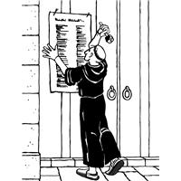
Introduction to the day
Rooted in the past and growing into the future, the church must always be reformed in order to live out the love of Christ in an ever-changing world. We celebrate the good news of God’s grace, that Jesus Christ sets us free every day to do this life-transforming work. Trusting in the freedom given to us in baptism, we pray for the church, that Christians will unite more fully in worship and mission.

SHARING OUR JOYS AND CONCERNS

Prelude

Gathering
The Holy Spirit calls us together as the people of God.

GATHERING SONG: A Mighty Fortress Is Our God 504

Confession and Forgiveness
Blessed be God,
the one who forms us,
☩ Jesus who bears the cross,
the Spirit who makes our joy complete.
Amen.
Let us bow before God in humility,
confessing our sin.
Silence is kept for reflection.
Steadfast and faithful God,
you have revealed the ways of justice,
yet we fail to follow you.
We are overwhelmed
by the world’s violence and suffering.
We are afraid to risk what we have
for the sake of others.
For the harm we have caused,
known and unknown, forgive us.
For the unjust demands we place on others
and your creation, forgive us.
For the ways we turn away
from you and our neighbor, forgive us.
Lead us back to you
and set us on the right path;
in the name of Jesus Christ, our Savior.
Amen.
Beloved in Christ,
God’s justice stretches beyond all understanding.
God’s compassion is beyond compare.
In Jesus, God is always making a new way for us.
In ☩ Christ, you are already and always forgiven.
Amen.

Hymn of PRAISE: This Is the Feast p.140

Greeting
P: The grace of our Lord Jesus Christ, the love of God,
and the communion of the Holy Spirit be with you all.
C: And also, with you.

Prayer of the Day
P: Let us pray.
Almighty God, gracious Lord, we thank you that your Holy Spirit renews the church in every age. Pour out your Holy Spirit on your faithful people. Keep them steadfast in your word, protect and comfort them in times of trial, defend them against all enemies of the gospel, and bestow on the church your saving peace, through Jesus Christ, our Savior and Lord, who lives and reigns with you and the Holy Spirit, one God, now and forever.
Amen.

The assembly is seated.

CHILDREN'S CHURCH SKIT Feeding the 5000

Word
God speaks to us in scripture reading, preaching, and song.

A reading from Jeremiah.

First Reading: Jeremiah 31:31-34
The renewed covenant will not be breakable, but like the old covenant it will expect the people to live upright lives. To know the Lord means that one will defend the cause of the poor and needy (Jer. 22:16). The renewed covenant is possible only because the Lord will forgive iniquity and not remember sin. Our hope lies in a God who forgets.
³¹The days are surely coming, says the Lord, when I will make a new covenant with the house of Israel and the house of Judah. ³²It will not be like the covenant that I made with their ancestors when I took them by the hand to bring them out of the land of Egypt—a covenant that they broke, though I was their husband, says the Lord. ³³But this is the covenant that I will make with the house of Israel after those days, says the Lord: I will put my law within them, and I will write it on their hearts; and I will be their God, and they shall be my people. ³⁴No longer shall they teach one another, or say to each other, “Know the Lord,” for they shall all know me, from the least of them to the greatest, says the Lord; for I will forgive their iniquity, and remember their sin no more.

L: The word of the Lord.
C: Thanks be to God.

L: Let us read the Psalm responsively by verse.

Psalm: Psalm 46
¹God is our refuge and strength,
a very present help in trouble.
²Therefore we will not fear, though the earth be moved,
and though the mountains shake in the depths of the sea;
³though its waters rage and foam,
and though the mountains tremble with its tumult.
⁴There is a river whose streams make glad the city of God,
the holy habitation of the Most High.
⁵God is in the midst of the city; it shall not be shaken;
God shall help it at the break of day.
⁶The nations rage, and the kingdoms shake;
God speaks, and the earth melts away.
⁷The Lord of hosts is with us;
the God of Jacob is our stronghold.
⁸Come now, regard the works of the Lord,
what desolations God has brought upon the earth;
⁹behold the one who makes war to cease in all the world;
who breaks the bow, and shatters the spear, and burns the shields with fire.
¹⁰“Be still, then, and know that I am God;
I will be exalted among the nations; I will be exalted in the earth.”
¹¹The Lord of hosts is with us;
the God of Jacob |is our stronghold.

L: A reading from Romans, the third chapter.

Second Reading: Romans 3:19-28
Paul’s words stand at the heart of the preaching of Martin Luther and other Reformation leaders. No human beings make themselves right with God through works of the law. We are brought into a right relationship with God through the divine activity centered in Christ’s death. This act is a gift of grace that liberates us from sin and empowers our faith in Jesus Christ.
¹⁹Now we know that whatever the law says, it speaks to those who are under the law, so that every mouth may be silenced, and the whole world may be held accountable to God. ²⁰For “no human being will be justified in his sight” by deeds prescribed by the law, for through the law comes the knowledge of sin.
²¹But now, apart from law, the righteousness of God has been disclosed, and is attested by the law and the prophets, ²²the righteousness of God through faith in Jesus Christ for all who believe. For there is no distinction, ²³since all have sinned and fall short of the glory of God; ²⁴they are now justified by his grace as a gift, through the redemption that is in Christ Jesus, ²⁵whom God put forward as a sacrifice of atonement by his blood, effective through faith. He did this to show his righteousness, because in his divine forbearance he had passed over the sins previously committed; ²⁶it was to prove at the present time that he himself is righteous and that he justifies the one who has faith in Jesus.
²⁷Then what becomes of boasting? It is excluded. By what law? By that of works? No, but by the law of faith. ²⁸For we hold that a person is justified by faith apart from works prescribed by the law.

L: The word of the Lord.
C: Thanks be to God.
The assembly stands.
Gospel Acclamation p.142
Alleluia Lord to whom shall we go?
You have the words of eternal life. Alleluia, Alleluia.

P: The holy gospel according to Luke.
C: Glory to you, O Lord,

Gospel: John 8:31-36
Jesus speaks of truth and freedom as spiritual realities known through his word. He reveals the truth that sets people free from sin.
³¹Jesus said to the Jews who had believed in him, “If you continue in my word, you are truly my disciples; ³²and you will know the truth, and the truth will make you free.” ³³They answered him, “We are descendants of Abraham and have never been slaves to anyone. What do you mean by saying, ‘You will be made free’?”
³⁴Jesus answered them, “Very truly, I tell you, everyone who commits sin is a slave to sin. ³⁵The slave does not have a permanent place in the household; the son has a place there forever. ³⁶So if the Son makes you free, you will be free indeed.”

P: The gospel of the Lord.
C: Praise to you, O Christ.

The assembly is seated.

Sermon

Hymn of the Day: God of Our Fathers (from LBW)
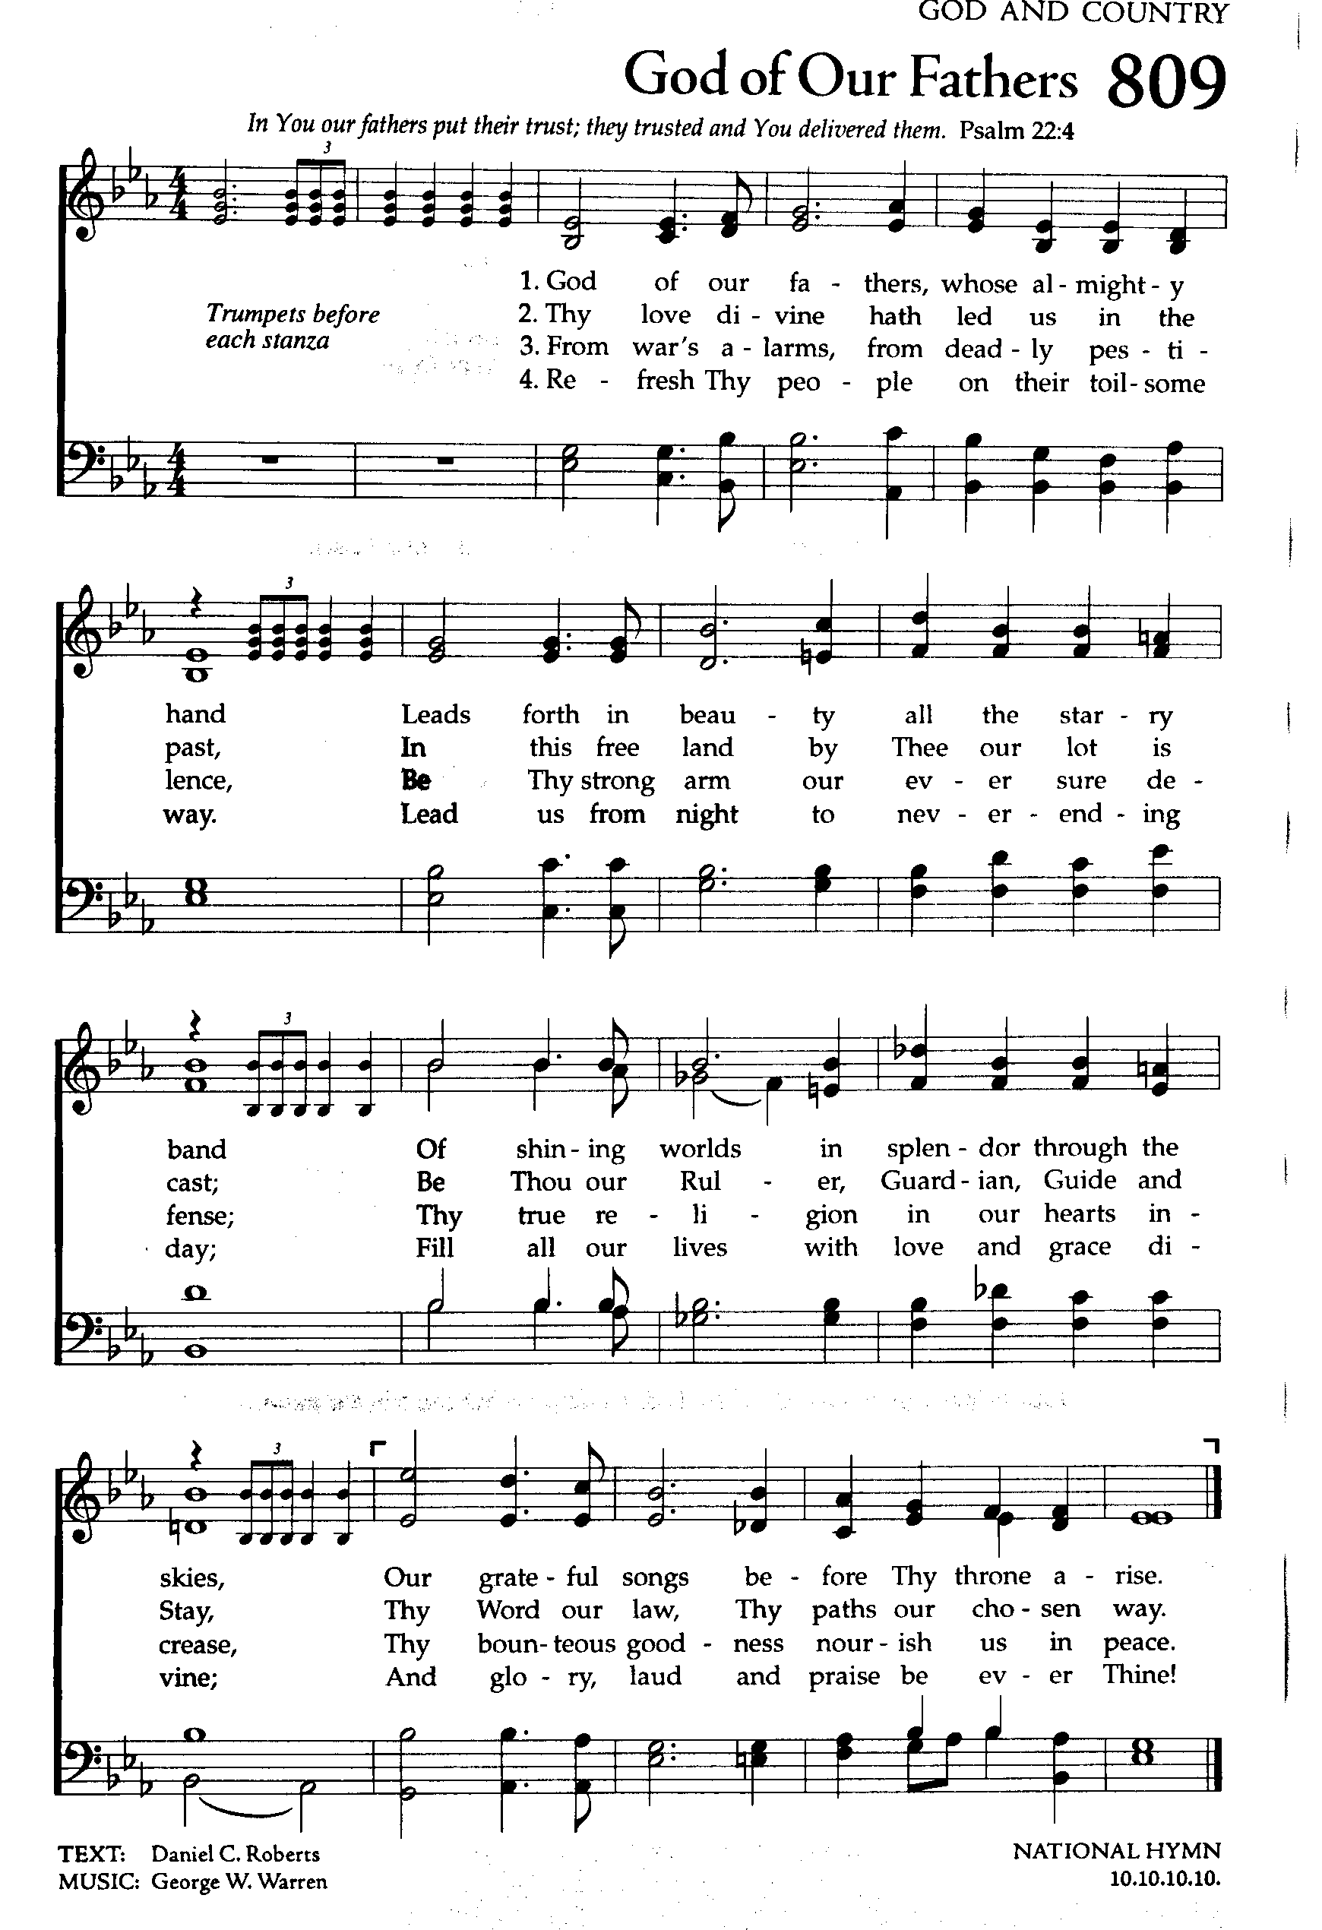
THE NICENE CREED
We believe in one God,
the Father, the Almighty,
maker of heaven and earth,
of all that is, seen and unseen.
We believe in one Lord, Jesus Christ,
the only Son of God,
eternally begotten of the Father,
God from God, Light from Light,
true God from true God,
begotten, not made,
of one Being with the Father;
through him all things were made.
For us and for our salvation
he came down from heaven,
was incarnate of the Holy Spirit and the virgin Mary
and became truly human.
For our sake he was crucified under Pontius Pilate;
he suffered death and was buried.
On the third day he rose again
in accordance with the scriptures;
he ascended into heaven
and is seated at the right hand of the Father.
He will come again in glory to judge the living and the dead,
and his kingdom will have no end.
We believe in the Holy Spirit, the Lord, the giver of life,
who proceeds from the Father and the Son,*
who with the Father and the Son is worshiped and glorified,
who has spoken through the prophets.
We believe in one holy catholic and apostolic church.
We acknowledge one baptism for the forgiveness of sins.
We look for the resurrection of the dead,
and the life of the world to come. Amen.

Prayers of Intercession
A: Trusting in the transformative power of God’s loving Spirit, let us pray for the church, the world, and all in need.
A brief silence.
God our parent, you call us your children and have made us siblings through your son Jesus. Heal the church’s many divisions, bring understanding and peace where there has been contention and strife, and unite us in one body through the love of Christ. God of grace,
C: hear our prayer.
A: God our creator, your hands have made the heights of the mountains, the depths of the sea, and the life that animates all creation. Bring relief to areas harmed by wildfires, floods, storms, and human carelessness (especially). Renew the face of the earth. God of grace,
C: hear our prayer.
A: God our ruler, the nations rage and the kingdoms shake, but your word stands fast forever. Let your justice and peace roll down like waters wherever there is strife, injustice, war, or religious conflict (especially). God of grace,
C: hear our prayer.
A: God our champion, you are our refuge and strength, a very present help in times of trouble. Draw near to all who suffer (especially). Be their rest and comfort. God of grace,
C: hear our prayer.
A: God our reformer, you make all things new. Free us from complacency, open us to unexpected ways, and kindle zeal in us for the future. We pray for young people affirming their baptism. With them, stir in us a desire for your wisdom. God of grace,
C: hear our prayer.
A: On this day of Reformation Sunday, we remember the gospel message of grace through Jesus Christ as shared by Martin Luther. May we remember to share that hope and promise of God’s saving grace to those whom we meet each day. God of grace,
C: hear our prayer.
Here other intercessions may be offered.
A: God our savior, you made yourself known in the lives of all who have died in the hope of your grace. We give thanks for the witness of reformers like Martin Luther and for all whose example has brought us closer to you. God of grace,
C: hear our prayer.
P: Gracious God, into your hands we commend all for whom we pray, trusting in your unending love and amazing grace; through Jesus Christ, our Savior.
C: Amen.
The assembly is seated.

Our Offerings of Music

FAIRPLAY BRASS Just a Closer Walk with Thee

CHOIR ANTHEM Great and Awesome

The assembly stands.

Offering Prayer
A: God of power, God of plenty, all things belong to you.
We bring your gifts to the table, that all might be fed.
Form us into the body of your Beloved,
Jesus Christ, our Savior. Amen.

gREAT THANKSGIVING p.144 (in the beginning of the hymnal)
Dialogue
Preface by the Pastor
Holy Holy Holy

Thanksgiving at the Table
Words of Institution

Holy God, mighty Lord, gracious Father:
Endless is your mercy and eternal your reign.
You have filled all creation with light and life;
heaven and earth are full of your glory.

We praise you for the grace shown to your people in every age;
the promise to Israel, the rescue from Egypt,
the gift of the promised land,
the words of the prophets; and, at this end of all ages,
the gift of you Son, who proclaimed the good news in word and deed
and was obedient to your will, even to giving his life.

In the night in which he was betrayed,
our Lord Jesus took bread, and gave thanks;
broke it, and gave it to his disciples, saying:
Take and eat; this is my body, given for you.
Do this for the remembrance of me.

Again, after supper, he took the cup, gave thanks,
and gave it for all to drink, saying:
This cup is the new covenant in my blood,
shed for you and for all people for the forgiveness of sin.
Do this for the remembrance of me.
For as often as we eat of this bread and drink from this cup,
we proclaim the Lord’s death until he comes.

Christ has died.
Christ is risen.
Christ will come again.

Therefore, O God, with this bread and cup
we remember the life our Lord offered for us.
And, believing the witness of his resurrection,
we await his coming in power to share with us the great and promised feast.

Amen. Come, Lord Jesus.

Send now, we pray, your Holy Spirit, that we who share
in Christ’s body and blood and may live to the praise of your glory
and receive our inheritance with all your saints in light.

Amen. Come, Holy Spirit.

Join our prayers with those of your servants of every time and every place,
and unite them with the ceaseless petitions of our great high priest
until he comes as victorious Lord of all.
Through him, with him, in him, in the unity of the Holy Spirit,
all gory and honor is yours, almighty Father, now and forever. Amen.

THE LORD’S PRAYER P 145 (in the beginning of the hymnal)

Invitation to Communion
P: Christ invites you to this table.
Come, taste and see.

Communion
When giving the bread and cup, the communion ministers say
The body of Christ, given for you.
The blood of Christ, shed for you.
and each person may respond Amen.

Communion Song Lamb of God You Take Away p.146

Song after Communion Jesus, Name Above All Names
(repeat twice)
Jesus, name above all names, beautiful Savior, glorious Lord,
Emmanuel, God is with us, blessed Redeemer, living Word

The assembly stands.

Prayer after Communion
A: Blessed be your name, O God, for we have feasted on your Word,
Christ Jesus, the joy and delight of our hearts.
Strengthened by this food, send us to gather the world to your banquet,
where none are left out and all are satisfied. In Jesus’ name we pray.
Amen.

Sending
God blesses us and sends us in mission to the world.

Blessing
P: The God of glory,
☩ Jesus Christ, name above all names,
and the Spirit who lives in you,
bless you now and forever.
Amen.

Sending Song: The Church’s One Foundation 654

Dismissal
P: Go in peace. God is at work in you.
C: Thanks be to God.

POSTLUDE The Fairplay Brass
{Please remain seated until they finish playing}
{An offering basket is up front on the piano if you wish to leave them a donation}

Announcements
We welcome our visitors and ask that you sign a Visitor Attendance and Holy Communion Card that is located in the pew rack. We ask that cards be returned via the offering plate during the receiving of the offering. We practice “open Communion” here at St. John meaning that all who believe in the “real presence” of Christ are welcomed to receive the Sacrament of Holy Communion. We offer two choices for Holy Communion, wine or grape juice. Those worshipers desiring grape juice are asked at the communion rail to place their right hand over their heart after receiving “The Body of Christ.”

Remember in prayer: Rowan Aldridge, Jim Allen, Christine and Dave Barner, Linda Caris, Agnes Cryder, Don & Helen Delaney, Mary Ellen Doughtery, Joanne Fisher, Dawn Fryer, Dina George, Barb Hoffman, Mick Miller, Bob Moriarity, Elsie Parks in Haven Place, Cora Pelletier, Shane Snyder, and all of our shut-ins.

We also remember in prayer Family Promise; Presiding Bishop Elizabeth Eaton – ELCA; Bishop Craig A. Miller - USS; for our Companion Synods in Liberia and Ansbach-Wurzburg, Germany, and for peace in Ukraine and Israel.

We pray for the safety of our military troops around the world including Mark Baier, Isaac Boring, Jade Cordrey, Ben Cramer, Trevor and Nehemiah Eberhart, Patrick Hamlin, Paul Laidacker, Steven Moore, Maddison Myers, Tyler O’Neal, Adam Shaffer, Jeremy and Haley Naugle Sorrell, Richie Speicher, Aaron Stabley, Paul St. James, Kevin Titus, and Jenna White. We also lift up in prayer their families who strive to keep a normalcy in the family and continue on often with added stress.

Special thanks to this week’s helpers: Lector ––Pam Wehler; Assisting Ministers—Cozette Stoltzfus, Karen Aucker; Head Usher –Shelby Rice; Teller –Deb Heydrich; Bulletin Sponsor – Sue Willits.

Next weeks’ helpers: Lector –Kathy Brundick; Assisting Ministers -- Deb Heydrich and Ron Brundick; Head Usher –Dawn McCloskey; Teller – Shane Snyder; Bulletin Sponsor – Sue Willits; Children's Church -- Molly Hollick; Flowers-- Carl.

The flowers are in loving memory of Harris and Winifred Barner by Cynthis Breon.

The Sanctuary Candle in October is in honor of family birthdays by Agnus Cryder.

The Lutheran Church Women’s Prayer Chain is a vital ministry of St. John Lutheran. Anyone in need of prayers is asked to contact any of the following persons:
Gloria Ely – 570-873-3597 Joyce Braucht - 570-398-2852

An ENORMOUS THANK YOU to those who planned, decorated, contributed, donated and COOKED for the Chil Cook Off! The winner was….. The Pastor's Discretionary Fund!...which received $500 to assist those in need.

This bulletin and more can be found on our church website: www.stjl.org.

WOMEN OF THE CHURCH. A meeting is also planned for Sunday, November 19.

Pastor Aucker is hosting a First Communion class for anyone who has not completed instruction in the proper reception of the Sacrament of Holy Communion. The class will be held on Sunday, October 29 at 8:45 am in the Sanctuary. Children should come with their parents.

All Saints Sunday, November 5, 2023 we will be remembering
Candace Louise Welshans 3/10/2023 David Mitchell 4/14/2023
Jack Rishel 5/1/2023 Mary Jane Zinn 7/22/2023
Nancy Ott Wolfe 8/28/2023

Seafarer’s Bags are due November 1 (It’s fast approaching!) The bags, list, and directions are on the table in the office. Our very own Pastor Martha McCracken was on the board of Seafarer’s International and served as their president.

Ever have thoughts of being a missionary? Of serving in a ministry in another country for a short time period? We welcome all of our Middle School and High School Youth to join us on Sunday, November 19 for lunch and a presentation by Claire Weisner who served as a Young Adult in Global Missions in Argentina/Uruguay. Claire is from Trinity Lutheran, Milton, and will speak about her experiences providing ministry in two other countries. I’m sure there will be room if adults would like to join us. I’m setting up a Zoom meeting so if you cannot attend and want to join by zoom, contact Pastor Aucker. I would like to see all eighty of our youth attend.

HOLIDAY BUS TRIP Saturday, Dec. 2 with JS Garden Club. " A Delightful Day at Longwood Gardens." Details on the bulletin boards and see Molly Hollick.

SAVE THE DATE!! Christmas Bazaar will be Saturday, December 9.

Calendar
Sunday, October 29, 2023 Reformation Sunday
8:30 a.m. Adult Sunday School
8: 45 a.m. First Communion Class
9:30 a.m. Worship Service with FAIRPLAY BRASS
Seafarer Bags DUE
Monday, October 30, 2023 10:00 a.m. Bible Study
Wednesday, November 1, 2023 6:30 p.m. Choir Rehearsal
Saturday, November 4. 2023 9:00 a.m. Bazaar at St. James
TURN YOUR CLOCKS BACK !!
Sunday, November 5, 2023 All Saints Sunday Fall CASH SUNDAY
8:30 a.m.. Adult Sunday School
9:30 a.m. Worship Service with Children's Church

